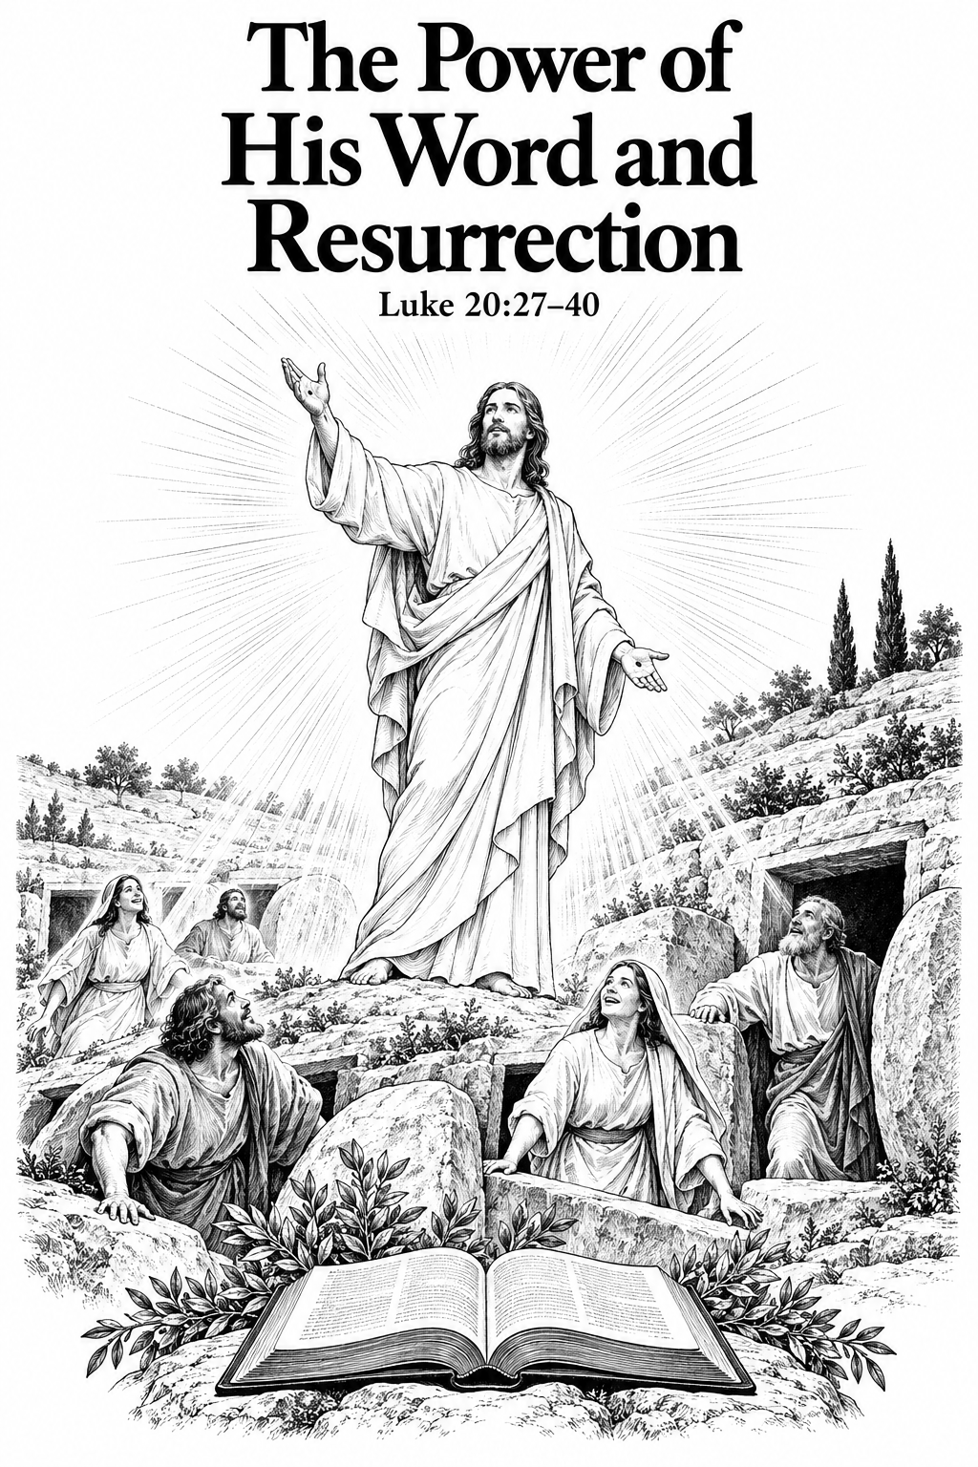

THE COMMON SERVICE
This liturgy is adapted from the Common Service Book of the Lutheran Church (1917-1918), Evangelical Lutheran Hymn-book (1912), and Music for the Liturgy: in Conformity with the Evangelical Lutheran Hymn book which are in the public domain.

OPENING HYMN 10, V:1-3
Leader : (The congregation rises.) In the name of the Father, and of the Son, and of the Holy Spirit.



THE CONFESSION OF SINS
L: Beloved in the Lord! Let us draw near with a true heart and confess our sins to God our Father, asking Him, in the name of our Lord Jesus Christ, to grant us forgiveness.
L: Our help is in the name of the Lord.

L: I said, I will confess my transgressions to the Lord.
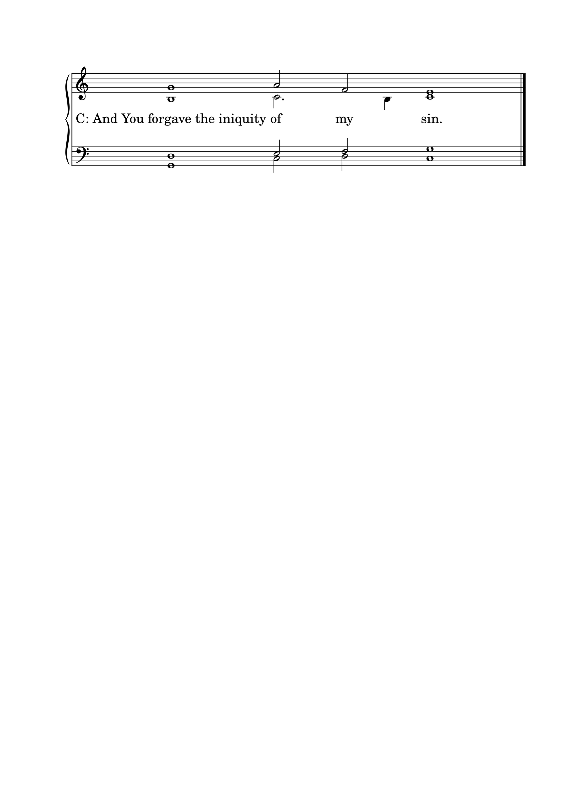

L : Almighty God, our Maker and Redeemer, we poor sinners confess to You that we are by nature sinful and unclean, and that we have sinned against You by thought, word, and deed. Therefore we flee for refuge to Your infinite mercy, seeking and imploring Your grace for the sake of our Lord Jesus Christ.
C: O most merciful God, who has given Your only-begotten Son to die for us, have mercy upon us, and for His sake grant us remission of all our sins; and by Your Holy Spirit increase in us true knowledge of You and of Your will, and true obedience to Your Word, so that by Your grace we may come to everlasting life; through Jesus Christ our Lord. Amen.

THE ABSOLUTION
L : Almighty God, our heavenly Father, has had mercy upon us and has given His only Son to die for us, and for His sake forgives us all our sins. To those who believe in His name He gives power to become the children of God and bestows upon them His Holy Spirit. Whoever believes and is baptized will be saved. Grant this, O Lord, to us all.
C: Amen.

PSALM OF THE DAY
L: When the Lord brought back the captivity of Zion,
C: We were like those who dream.
L: Then our mouth was filled with laughter, And our tongue with singing.
C: Then they said among the nations, “The Lord has done great things for them.”
L: The Lord has done great things for us,
C: And we are glad.
L: Bring back our captivity, O Lord,
C: As the streams in the South.
L: Those who sow in
C: tears Shall reap in joy.
L: He who continually goes forth weeping, Bearing seed for sowing,
C: Shall doubtless come again with rejoicing, Bringing his sheaves with him. (Psalm 126)

GLORIA PATRI

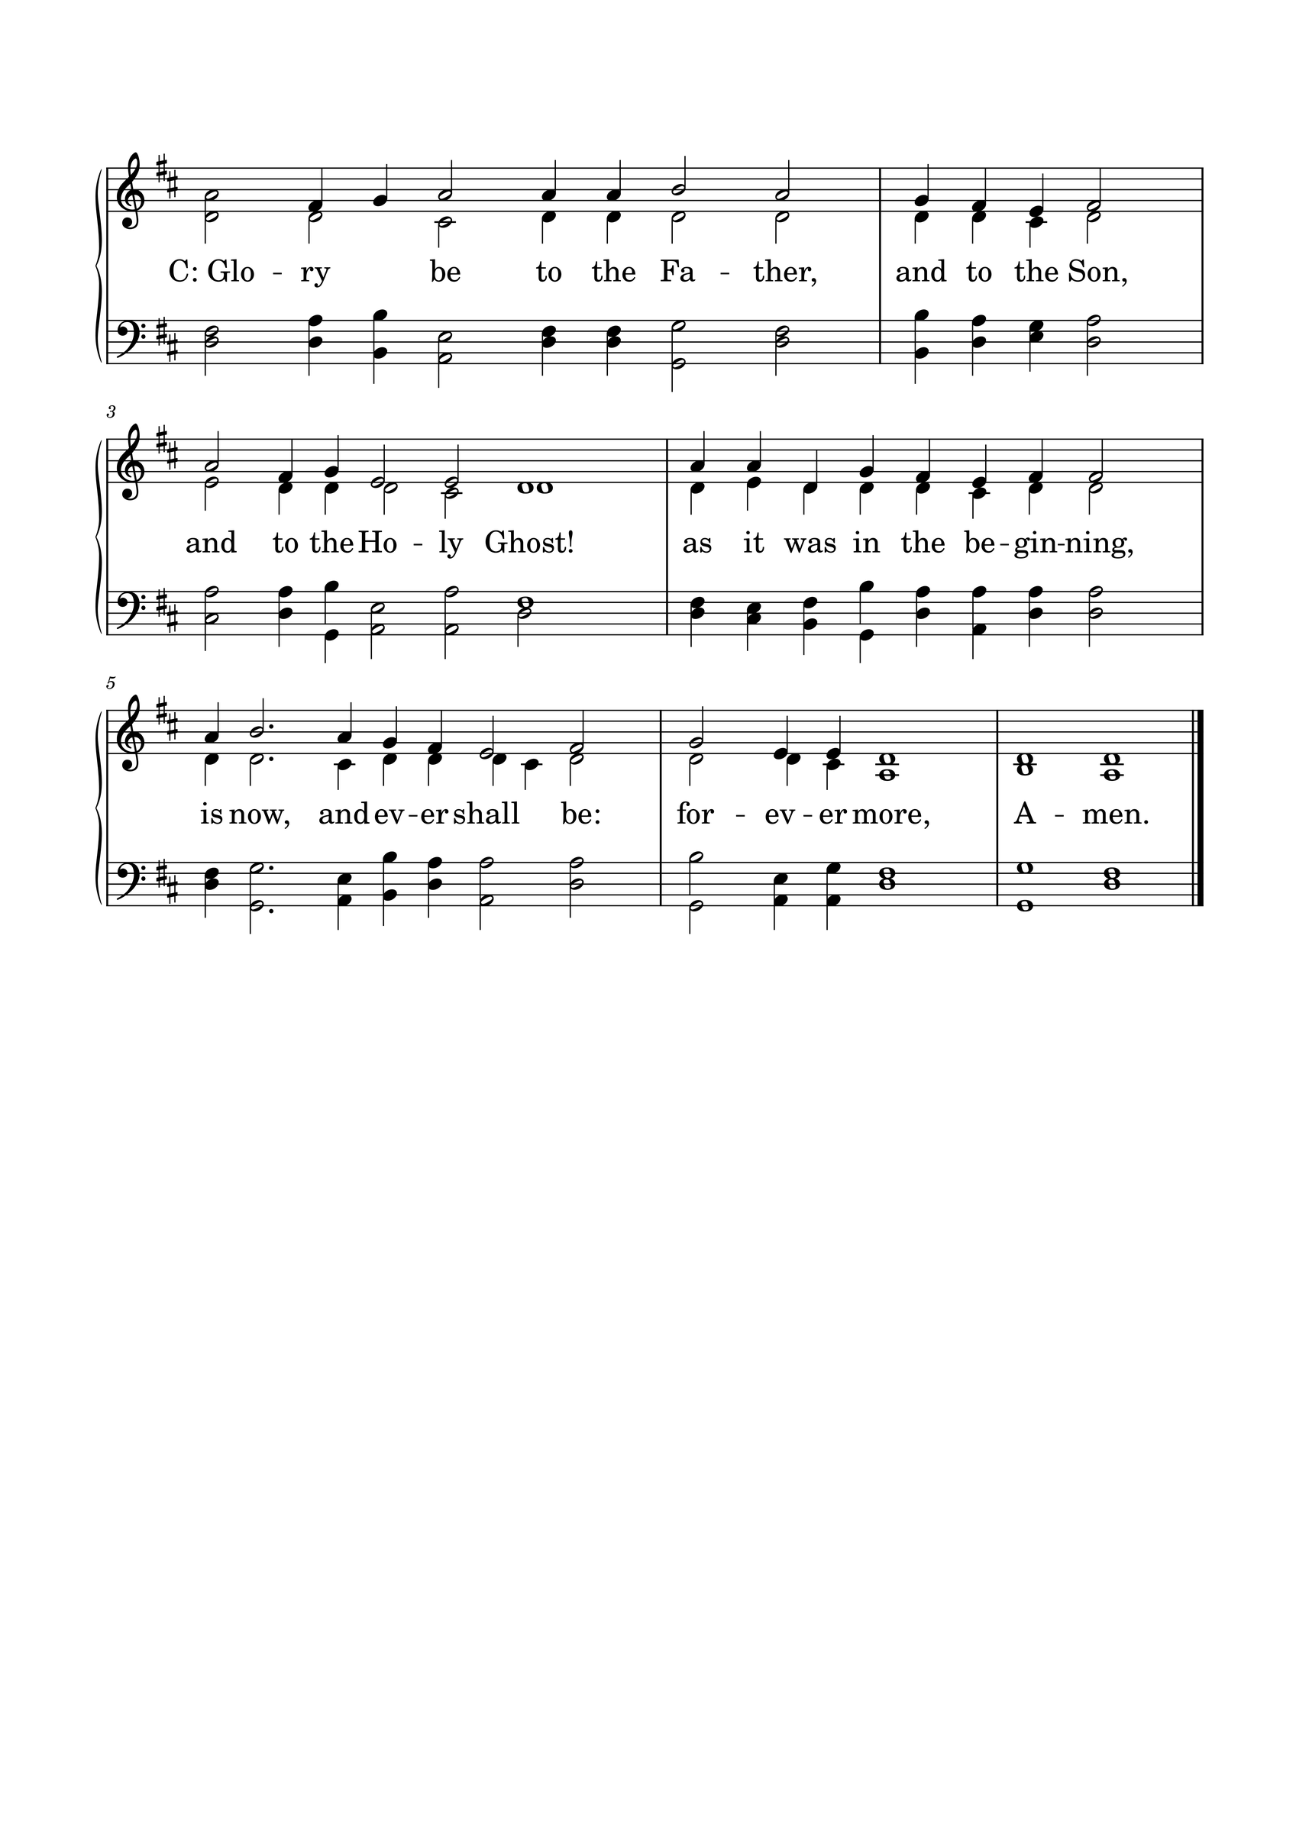

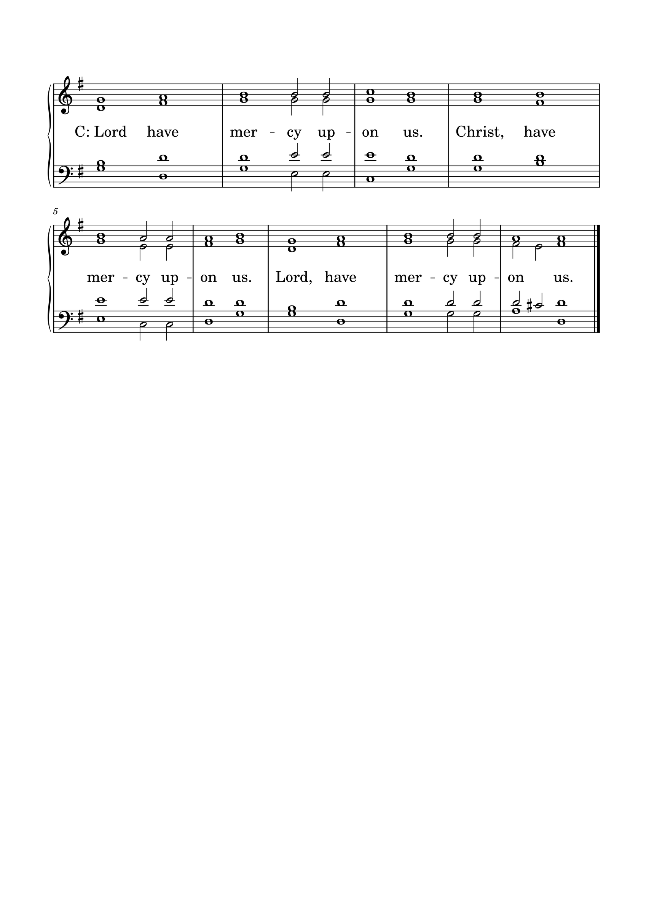KYRIE

GLORIA
The Lutheran Hymnal hymn 244 Verses 1 & 2
C: 1. Glory be to God the Father,
Glory be to God the Son,
Glory be to God the Spirit:
Great Jehovah, Three in One!
Glory, glory,
While eternal ages run!

2. Glory be to Him who loved us,
Washed us from each spot and stain;
Glory be to Him who bought us,
Made us kings with Him to reign!
Glory, glory,
To the Lamb that once was slain!

THE COLLECT
L : Let us pray.
L :
Living God, Your almighty power is made known chiefly in showing mercy and pity. Grant us the fullness of Your grace to lay hold of Your promises and live forever in Your presence through Jesus Christ, Your Son, Our Lord who lives and reigns with You and the Holy Spirit, one God,now and forever. Amen.
C: Amen.

FIRST SCRIPTURE READING
L: (The congregation may be seated.) The First Scripture Reading for 24th Sunday after Trinity is written in the 3rd chapter of Exodus, beginning at verse 1.
[1] Now Moses was tending the flock of Jethro his father-in-law, the priest of Midian. And he led the flock to the back of the desert, and came to Horeb, the mountain of God. [2] And the Angel of the Lord appeared to him in a flame of fire from the midst of a bush. So he looked, and behold, the bush was burning with fire, but the bush was not consumed. [3] Then Moses said, “I will now turn aside and see this great sight, why the bush does not burn.”
[4] So when the Lord saw that he turned aside to look, God called to him from the midst of the bush and said, “Moses, Moses!”
And he said, “Here I am.”
[5] Then He said, “Do not draw near this place. Take your sandals off your feet, for the place where you stand is holy ground.” [6] Moreover He said, “I am the God of your father—the God of Abraham, the God of Isaac, and the God of Jacob.” And Moses hid his face, for he was afraid to look upon God.
[7] And the Lord said: “I have surely seen the oppression of My people who are in Egypt, and have heard their cry because of their taskmasters, for I know their sorrows. [8] So I have come down to deliver them out of the hand of the Egyptians, and to bring them up from that land to a good and large land, to a land flowing with milk and honey, to the place of the Canaanites and the Hittites and the Amorites and the Perizzites and the Hivites and the Jebusites. [9] Now therefore, behold, the cry of the children of Israel has come to Me, and I have also seen the oppression with which the Egyptians oppress them. [10] Come now, therefore, and I will send you to Pharaoh that you may bring My people, the children of Israel, out of Egypt.”
[11] But Moses said to God, “Who am I that I should go to Pharaoh, and that I should bring the children of Israel out of Egypt?”
[12] So He said, “I will certainly be with you. And this shall be a sign to you that I have sent you: When you have brought the people out of Egypt, you shall serve God on this mountain.”
[13] Then Moses said to God, “Indeed, when I come to the children of Israel and say to them, ‘The God of your fathers has sent me to you,’ and they say to me, ‘What is His name?’ what shall I say to them?”
[14] And God said to Moses, “I AM WHO I AM.” And He said, “Thus you shall say to the children of Israel, ‘I AM has sent me to you.’ ” [15] Moreover God said to Moses, “Thus you shall say to the children of Israel: ‘The Lord God of your fathers, the God of Abraham, the God of Isaac, and the God of Jacob, has sent me to you. This is My name forever, and this is My memorial to all generations.’
L: Here ends the First Scripture Reading.

SECOND SCRIPTURE READING
L: The Second Scripture Reading is written in the 2nd chapter of 2 Thessalonians, beginning at verse 1.


[1] Now, brethren, concerning the coming of our Lord Jesus Christ and our gathering together to Him, we ask you, [2] not to be soon shaken in mind or troubled, either by spirit or by word or by letter, as if from us, as though the day of Christ had come. [3] Let no one deceive you by any means; for that Day will not come unless the falling away comes first, and the man of sin is revealed, the son of perdition, [4] who opposes and exalts himself above all that is called God or that is worshiped, so that he sits as God in the temple of God, showing himself that he is God.
[5] Do you not remember that when I was still with you I told you these things? [6] And now you know what is restraining, that he may be revealed in his own time. [7] For the mystery of lawlessness is already at work; only He who now restrains will do so until He is taken out of the way. [8] And then the lawless one will be revealed, whom the Lord will consume with the breath of His mouth and destroy with the brightness of His coming.
[13] But we are bound to give thanks to God always for you, brethren beloved by the Lord, because God from the beginning chose you for salvation through sanctification by the Spirit and belief in the truth, [14] to which He called you by our gospel, for the obtaining of the glory of our Lord Jesus Christ. [15] Therefore, brethren, stand fast and hold the traditions which you were taught, whether by word or our epistle.
[16] Now may our Lord Jesus Christ Himself, and our God and Father, who has loved us and given us everlasting consolation and good hope by grace, [17] comfort your hearts and establish you in every good word and work.

L: Here ends the Second Scripture Reading.



THE APOSTLES' CREED
C: I believe in God the Father almighty, maker of heaven and earth. And in Jesus Christ, His only Son, our Lord, who was conceived by the Holy Spirit, born of the Virgin Mary; suffered under Pontius Pilate, was crucified, died, and was buried. He descended into hell. The third day He rose again from the dead. He ascended into heaven and is seated at the right hand of God the Father almighty. From there He will come to judge the living and the dead. I believe in the Holy Spirit; the holy Christian Church, the communion of saints; the forgiveness of sins; the resurrection of the body; and the life everlasting. Amen.

HYMN 743

THE SERMON
Sermon Text: Luke 20:27-40 NKJ
Then some of the Sadducees, who deny that there is a resurrection, came to Him and asked Him, 28 saying: "Teacher, Moses wrote to us that if a man's brother dies, having a wife, and he dies without children, his brother should take his wife and raise up offspring for his brother. 29 "Now there were seven brothers. And the first took a wife, and died without children. 30 "And the second took her as wife, and he died childless. 31 "Then the third took her, and in like manner the seven also; and they left no children, and died. 32 "Last of all the woman died also. 33 "Therefore, in the resurrection, whose wife does she become? For all seven had her as wife." 34 And Jesus answered and said to them, "The sons of this age marry and are given in marriage. 35 "But those who are counted worthy to attain that age, and the resurrection from the dead, neither marry nor are given in marriage; 36 "nor can they die anymore, for they are equal to the angels and are sons of God, being sons of the resurrection. 37 "But even Moses showed in the burning bush passage that the dead are raised, when he called the Lord`the God of Abraham, the God of Isaac, and the God of Jacob.' 38 "For He is not the God of the dead but of the living, for all live to Him." 39 Then some of the scribes answered and said, "Teacher, You have spoken well." 40 But after that they dared not question Him anymore.

Sermon Theme: The Power of His Word and Resurrection

L: (The congregation rises.) And may the peace of God, which surpasses all understanding, guard your hearts and minds through Christ Jesus, amen.

THE OFFERTORY
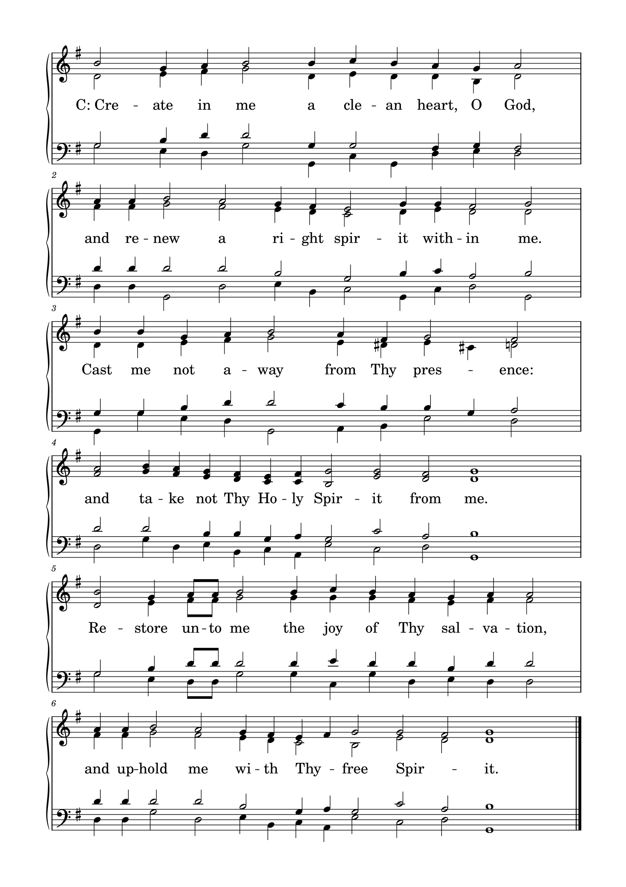

L: Please be seated.

(An offering may be collected at this time, or the congregation may be informed that the offering plate is located at the back of the church.)

HYMN 200, V: 1, 2, 7, 8

GENERAL PRAYER

THE LORD'S PRAYER
C: Our Father, who art in heaven, hallowed be Your name; Your kingdom come; Your will be done on earth as it is in heaven. Give us this day our daily bread; and forgive us our trespasses, as we forgive those who trespass against us; and lead us not into temptation; but deliver us from evil. For Yours is the kingdom and the power and the glory forever and ever. Amen.

(If Communion is celebrated, refer to the order of Holy Communion.)

FINAL HYMN 46

THE BENEDICTION
L : (The congregation rises.) The Lord bless you and keep you. The Lord make His face shine upon you and be gracious to you. The Lord lift up His countenance upon you and give you peace.


ANNOUNCEMENTS
• Immanuel Lutheran College Visitors' Day is coming up on Friday, November 13th on the ILC campus in Eau Claire, Wisconsin. Activities will begin with chapel at 10:05 A.M. in the Field House, followed by presentations and classroom visits until 2:50 p.m. Come and learn more about your church's college, and consider continuing your education in a solidly Christian setting! Visitors will be our guests for lunch and supper in the cafeteria, and in the evening are invited to join us for ILC's fall theatrical production, The Sound of Music. Speak with your pastor if you're interested in attending. For questions, contact Academic Dean Paul Naumann. Office: 715-836-6636, cell: 253-228-8736, e‑mail: paul.naumann@ilc.edu
• Used smartphones for Africa - Once again, Missionary Bruce Naumann is requesting donations of a certain kind of used smartphone, for use by pastors and pastoral students in East Africa. The need is for used phones that were once on a Verizon plan (or you know that they are otherwise "unlocked"). Please do a factory reset on the phone and tape your name and your church's name on it. Bring it to the church office and it will find its way to Africa. These phones are much appreciated by students and pastors in our sister African churches - thank you!
• CALL NEWS Pastor Rob Sauers of Immanuel Lutheran Church, Winter Haven, FL, has returned the call from the CLC Board of Missions to serve as Part-Time Missionary to India. <> Pastor Frank Gantt of Zion Ev. Lutheran Church, Loganville, GA, and Faith Lutheran Church, Manchester, MO, has returned the call to St. Luke’s Ev. Lutheran Church, Lemmon, SD. <> Pastor Paul Krause of Trinity Lutheran Church, Watertown, SD, and Zion Lutheran Church, Hidewood Township, SD, has accepted the call to Mt. Zion Lutheran Church, Madison Heights, MI. <> Pastor Neal Radichel of Messiah Lutheran Church, Eau Claire, WI, has received the call to Holy Cross Ev. Lutheran Church, Phoenix, AZ. <> Pastor Michael Wilke of Gethsemane Lutheran Church, Saginaw, MI, has received the call to Gift of God Lutheran Church, Mapleton, ND, and to St. Paul’s Lutheran Church, Ponsford, MN.

“Scripture taken from the New King James Version®. Copyright © 1982 by Thomas Nelson. Used by permission. All rights reserved.”

