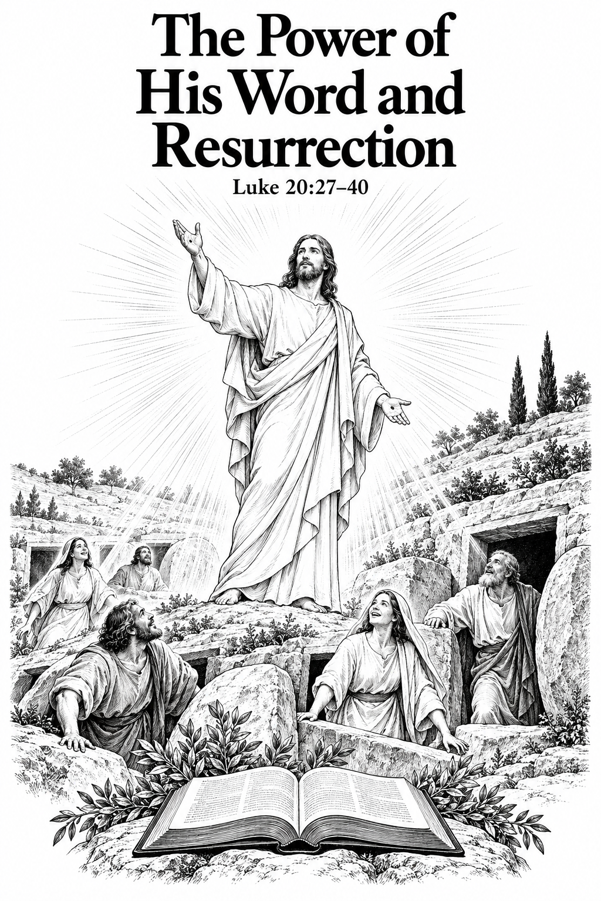
A Church of the Lutheran Confession
November 8, 2026
24th Sunday after Trinity

HYMNS
10 V:1-3; 743; 200 V: 1, 2, 7, 8; 46

PSALM OF THE DAY
L: When the Lord brought back the captivity of Zion,
C: We were like those who dream.
L: Then our mouth was filled with laughter, And our tongue with singing.
C: Then they said among the nations, “The Lord has done great things for them.”
L: The Lord has done great things for us,
C: And we are glad.
L: Bring back our captivity, O Lord,
C: As the streams in the South.
L: Those who sow in
C: tears Shall reap in joy.
L: He who continually goes forth weeping, Bearing seed for sowing,
C: Shall doubtless come again with rejoicing, Bringing his sheaves with him. (Psalm 126)

THE COLLECT
Living God, Your almighty power is made known chiefly in showing mercy and pity. Grant us the fullness of Your grace to lay hold of Your promises and live forever in Your presence through Jesus Christ, Your Son, Our Lord who lives and reigns with You and the Holy Spirit, one God,now and forever. Amen.

FIRST SCRIPTURE READING
Exodus 3:1-15: [1] Now Moses was tending the flock of Jethro his father-in-law, the priest of Midian. And he led the flock to the back of the desert, and came to Horeb, the mountain of God. [2] And the Angel of the Lord appeared to him in a flame of fire from the midst of a bush. So he looked, and behold, the bush was burning with fire, but the bush was not consumed. [3] Then Moses said, “I will now turn aside and see this great sight, why the bush does not burn.”
[4] So when the Lord saw that he turned aside to look, God called to him from the midst of the bush and said, “Moses, Moses!” And he said, “Here I am.”
[5] Then He said, “Do not draw near this place. Take your sandals off your feet, for the place where you stand is holy ground.” [6] Moreover He said, “I am the God of your father—the God of Abraham, the God of Isaac, and the God of Jacob.” And Moses hid his face, for he was afraid to look upon God.
[7] And the Lord said: “I have surely seen the oppression of My people who are in Egypt, and have heard their cry because of their taskmasters, for I know their sorrows. [8] So I have come down to deliver them out of the hand of the Egyptians, and to bring them up from that land to a good and large land, to a land flowing with milk and honey, to the place of the Canaanites and the Hittites and the Amorites and the Perizzites and the Hivites and the Jebusites. [9] Now therefore, behold, the cry of the children of Israel has come to Me, and I have also seen the oppression with which the Egyptians oppress them. [10] Come now, therefore, and I will send you to Pharaoh that you may bring My people, the children of Israel, out of Egypt.” [11] But Moses said to God, “Who am I that I should go to Pharaoh, and that I should bring the children of Israel out of Egypt?” [12] So He said, “I will certainly be with you. And this shall be a sign to you that I have sent you: When you have brought the people out of Egypt, you shall serve God on this mountain.”
[13] Then Moses said to God, “Indeed, when I come to the children of Israel and say to them, ‘The God of your fathers has sent me to you,’ and they say to me, ‘What is His name?’ what shall I say to them?”
[14] And God said to Moses, “I AM WHO I AM.” And He said, “Thus you shall say to the children of Israel, ‘I AM has sent me to you.’ ” [15] Moreover God said to Moses, “Thus you shall say to the children of Israel: ‘The Lord God of your fathers, the God of Abraham, the God of Isaac, and the God of Jacob, has sent me to you. This is My name forever, and this is My memorial to all generations.’

SECOND SCRIPTURE READING
2 Thessalonians 2:1-8, 13-17: [1] Now, brethren, concerning the coming of our Lord Jesus Christ and our gathering together to Him, we ask you, [2] not to be soon shaken in mind or troubled, either by spirit or by word or by letter, as if from us, as though the day of Christ had come. [3] Let no one deceive you by any means; for that Day will not come unless the falling away comes first, and the man of sin is revealed, the son of perdition, [4] who opposes and exalts himself above all that is called God or that is worshiped, so that he sits as God in the temple of God, showing himself that he is God.
[5] Do you not remember that when I was still with you I told you these things? [6] And now you know what is restraining, that he may be revealed in his own time. [7] For the mystery of lawlessness is already at work; only He who now restrains will do so until He is taken out of the way. [8] And then the lawless one will be revealed, whom the Lord will consume with the breath of His mouth and destroy with the brightness of His coming.
[13] But we are bound to give thanks to God always for you, brethren beloved by the Lord, because God from the beginning chose you for salvation through sanctification by the Spirit and belief in the truth, [14] to which He called you by our gospel, for the obtaining of the glory of our Lord Jesus Christ. [15] Therefore, brethren, stand fast and hold the traditions which you were taught, whether by word or our epistle.
[16] Now may our Lord Jesus Christ Himself, and our God and Father, who has loved us and given us everlasting consolation and good hope by grace, [17] comfort your hearts and establish you in every good word and work.

THE SERMON
Sermon Text: Luke 20:27-40 NKJ
Then some of the Sadducees, who deny that there is a resurrection, came to Him and asked Him, 28 saying: "Teacher, Moses wrote to us that if a man's brother dies, having a wife, and he dies without children, his brother should take his wife and raise up offspring for his brother. 29 "Now there were seven brothers. And the first took a wife, and died without children. 30 "And the second took her as wife, and he died childless. 31 "Then the third took her, and in like manner the seven also; and they left no children, and died. 32 "Last of all the woman died also. 33 "Therefore, in the resurrection, whose wife does she become? For all seven had her as wife." 34 And Jesus answered and said to them, "The sons of this age marry and are given in marriage. 35 "But those who are counted worthy to attain that age, and the resurrection from the dead, neither marry nor are given in marriage; 36 "nor can they die anymore, for they are equal to the angels and are sons of God, being sons of the resurrection. 37 "But even Moses showed in the burning bush passage that the dead are raised, when he called the Lord`the God of Abraham, the God of Isaac, and the God of Jacob.' 38 "For He is not the God of the dead but of the living, for all live to Him." 39 Then some of the scribes answered and said, "Teacher, You have spoken well." 40 But after that they dared not question Him anymore.

Sermon Theme: The Power of His Word and Resurrection

“Scripture taken from the New King James Version®. Copyright © 1982 by Thomas Nelson. Used by permission. All rights reserved.”

