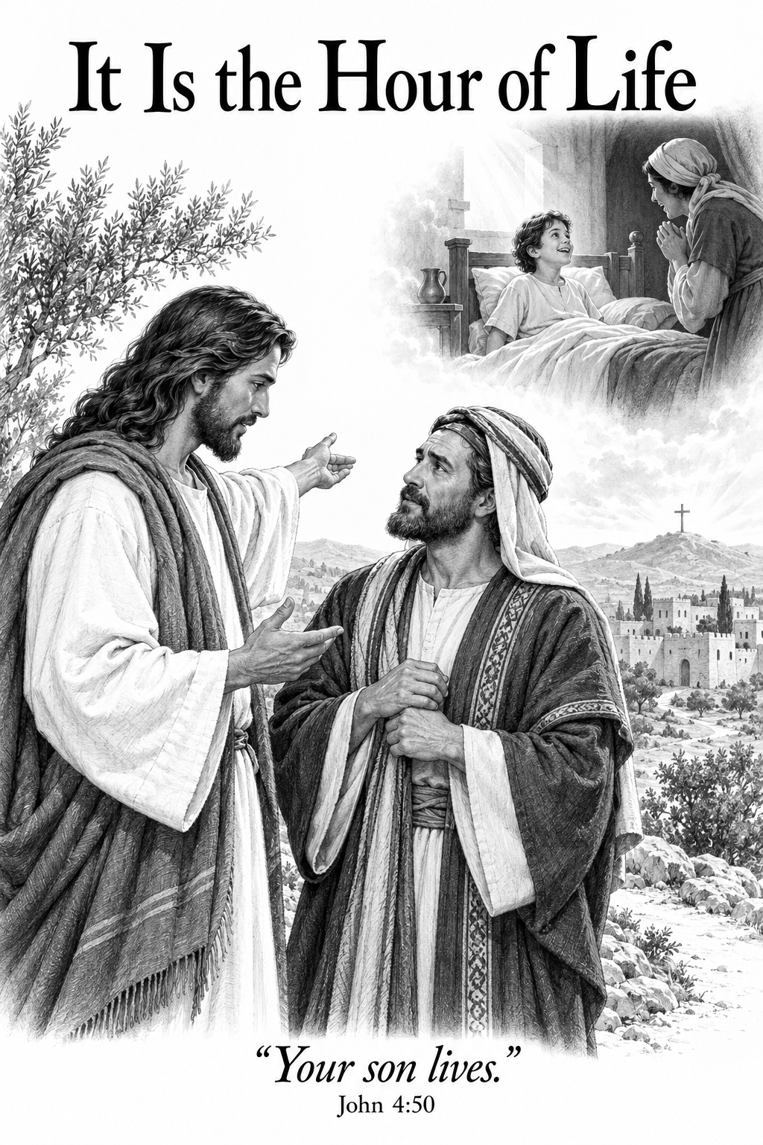

THE COMMON SERVICE
This liturgy is adapted from the Common Service Book of the Lutheran Church (1917-1918), Evangelical Lutheran Hymn-book (1912), and Music for the Liturgy: in Conformity with the Evangelical Lutheran Hymn book which are in the public domain.

OPENING HYMN 23
Leader : (The congregation rises.) In the name of the Father, and of the Son, and of the Holy Spirit.



THE CONFESSION OF SINS
L: Beloved in the Lord! Let us draw near with a true heart and confess our sins to God our Father, asking Him, in the name of our Lord Jesus Christ, to grant us forgiveness.
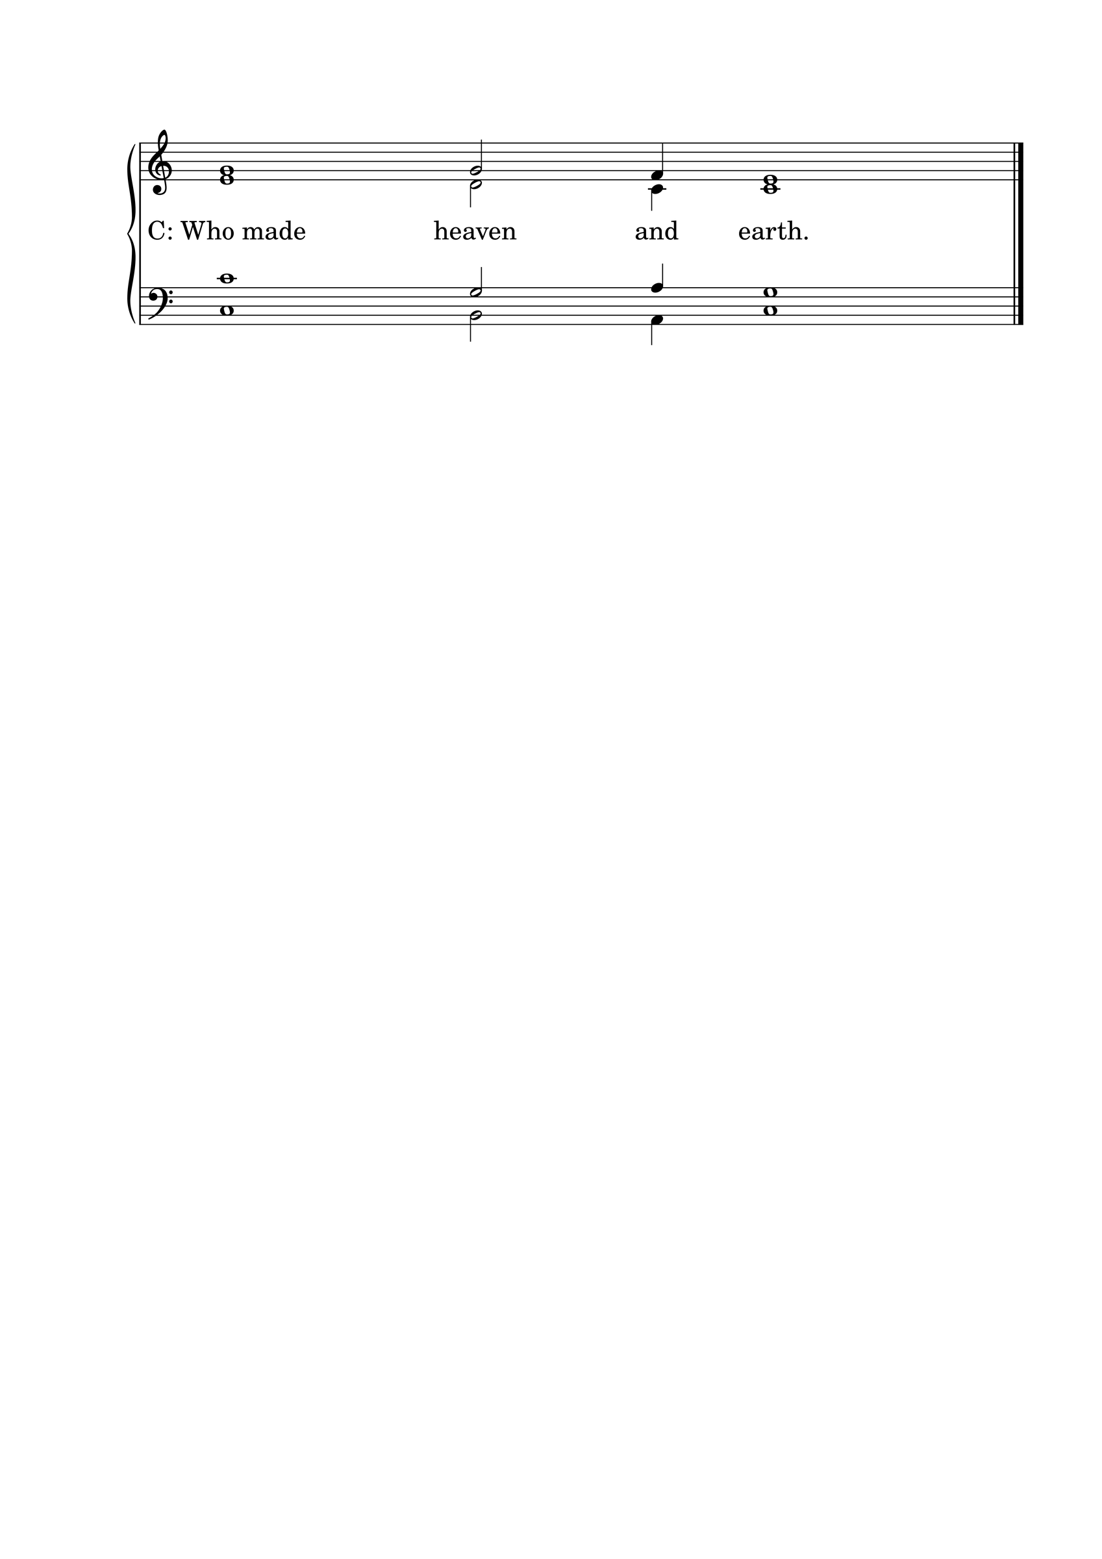L: Our help is in the name of the Lord.

L: I said, I will confess my transgressions to the Lord.
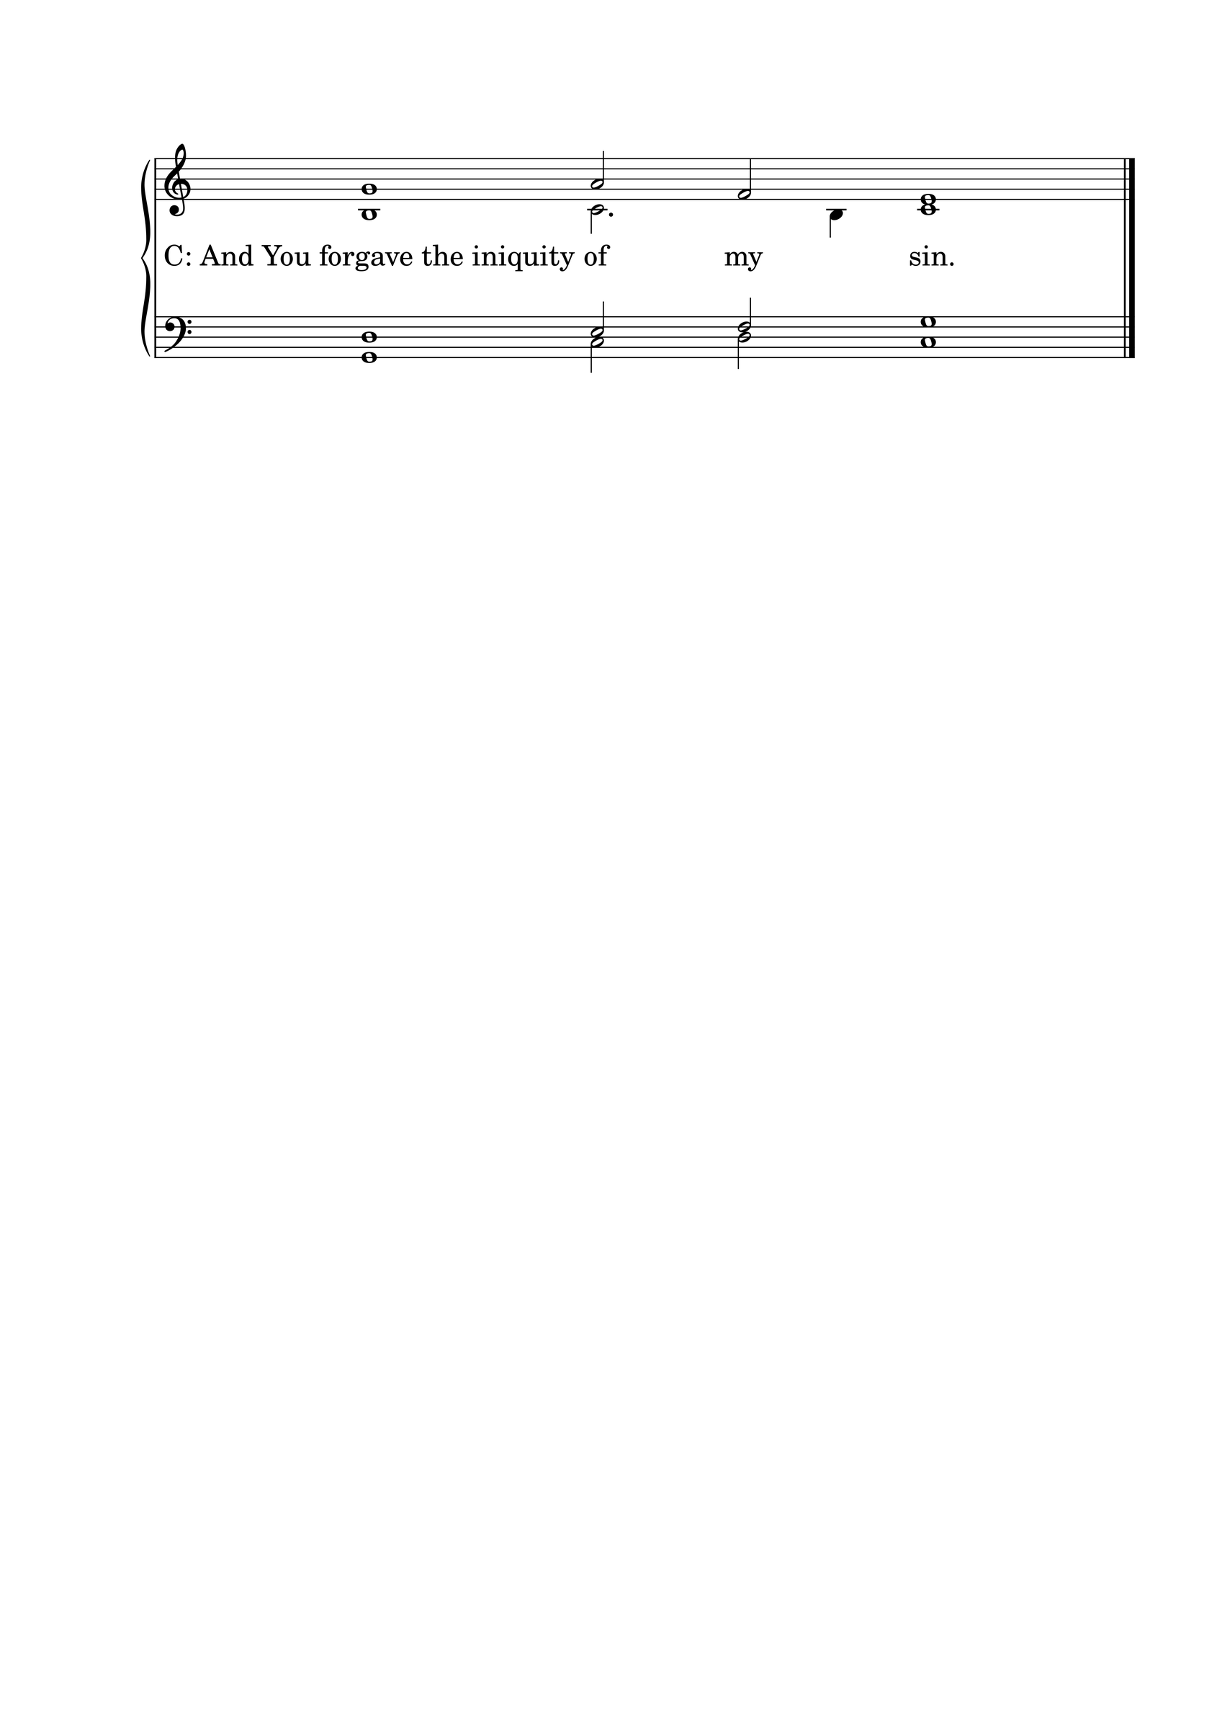

L : Almighty God, our Maker and Redeemer, we poor sinners confess to You that we are by nature sinful and unclean, and that we have sinned against You by thought, word, and deed. Therefore we flee for refuge to Your infinite mercy, seeking and imploring Your grace for the sake of our Lord Jesus Christ.
C: O most merciful God, who has given Your only-begotten Son to die for us, have mercy upon us, and for His sake grant us remission of all our sins; and by Your Holy Spirit increase in us true knowledge of You and of Your will, and true obedience to Your Word, so that by Your grace we may come to everlasting life; through Jesus Christ our Lord. Amen.

THE ABSOLUTION
L : Almighty God, our heavenly Father, has had mercy upon us and has given His only Son to die for us, and for His sake forgives us all our sins. To those who believe in His name He gives power to become the children of God and bestows upon them His Holy Spirit. Whoever believes and is baptized will be saved. Grant this, O Lord, to us all.
C: Amen.

PSALM OF THE DAY
L: Lord, You have been favorable to Your land;
C: You have brought back the captivity of Jacob.
L: You have forgiven the iniquity of Your people;
C: You have covered all their sin. Selah
L: You have taken away all Your wrath;
C: You have turned from the fierceness of Your anger.
L: Restore us, O God of our salvation,
C: And cause Your anger toward us to cease.
L: Will You be angry with us forever?
C: Will You prolong Your anger to all generations?
L: Will You not revive us again,
C: That Your people may rejoice in You?
L: Show us Your mercy, Lord,
C: And grant us Your salvation. (Psalm 85)

GLORIA PATRI

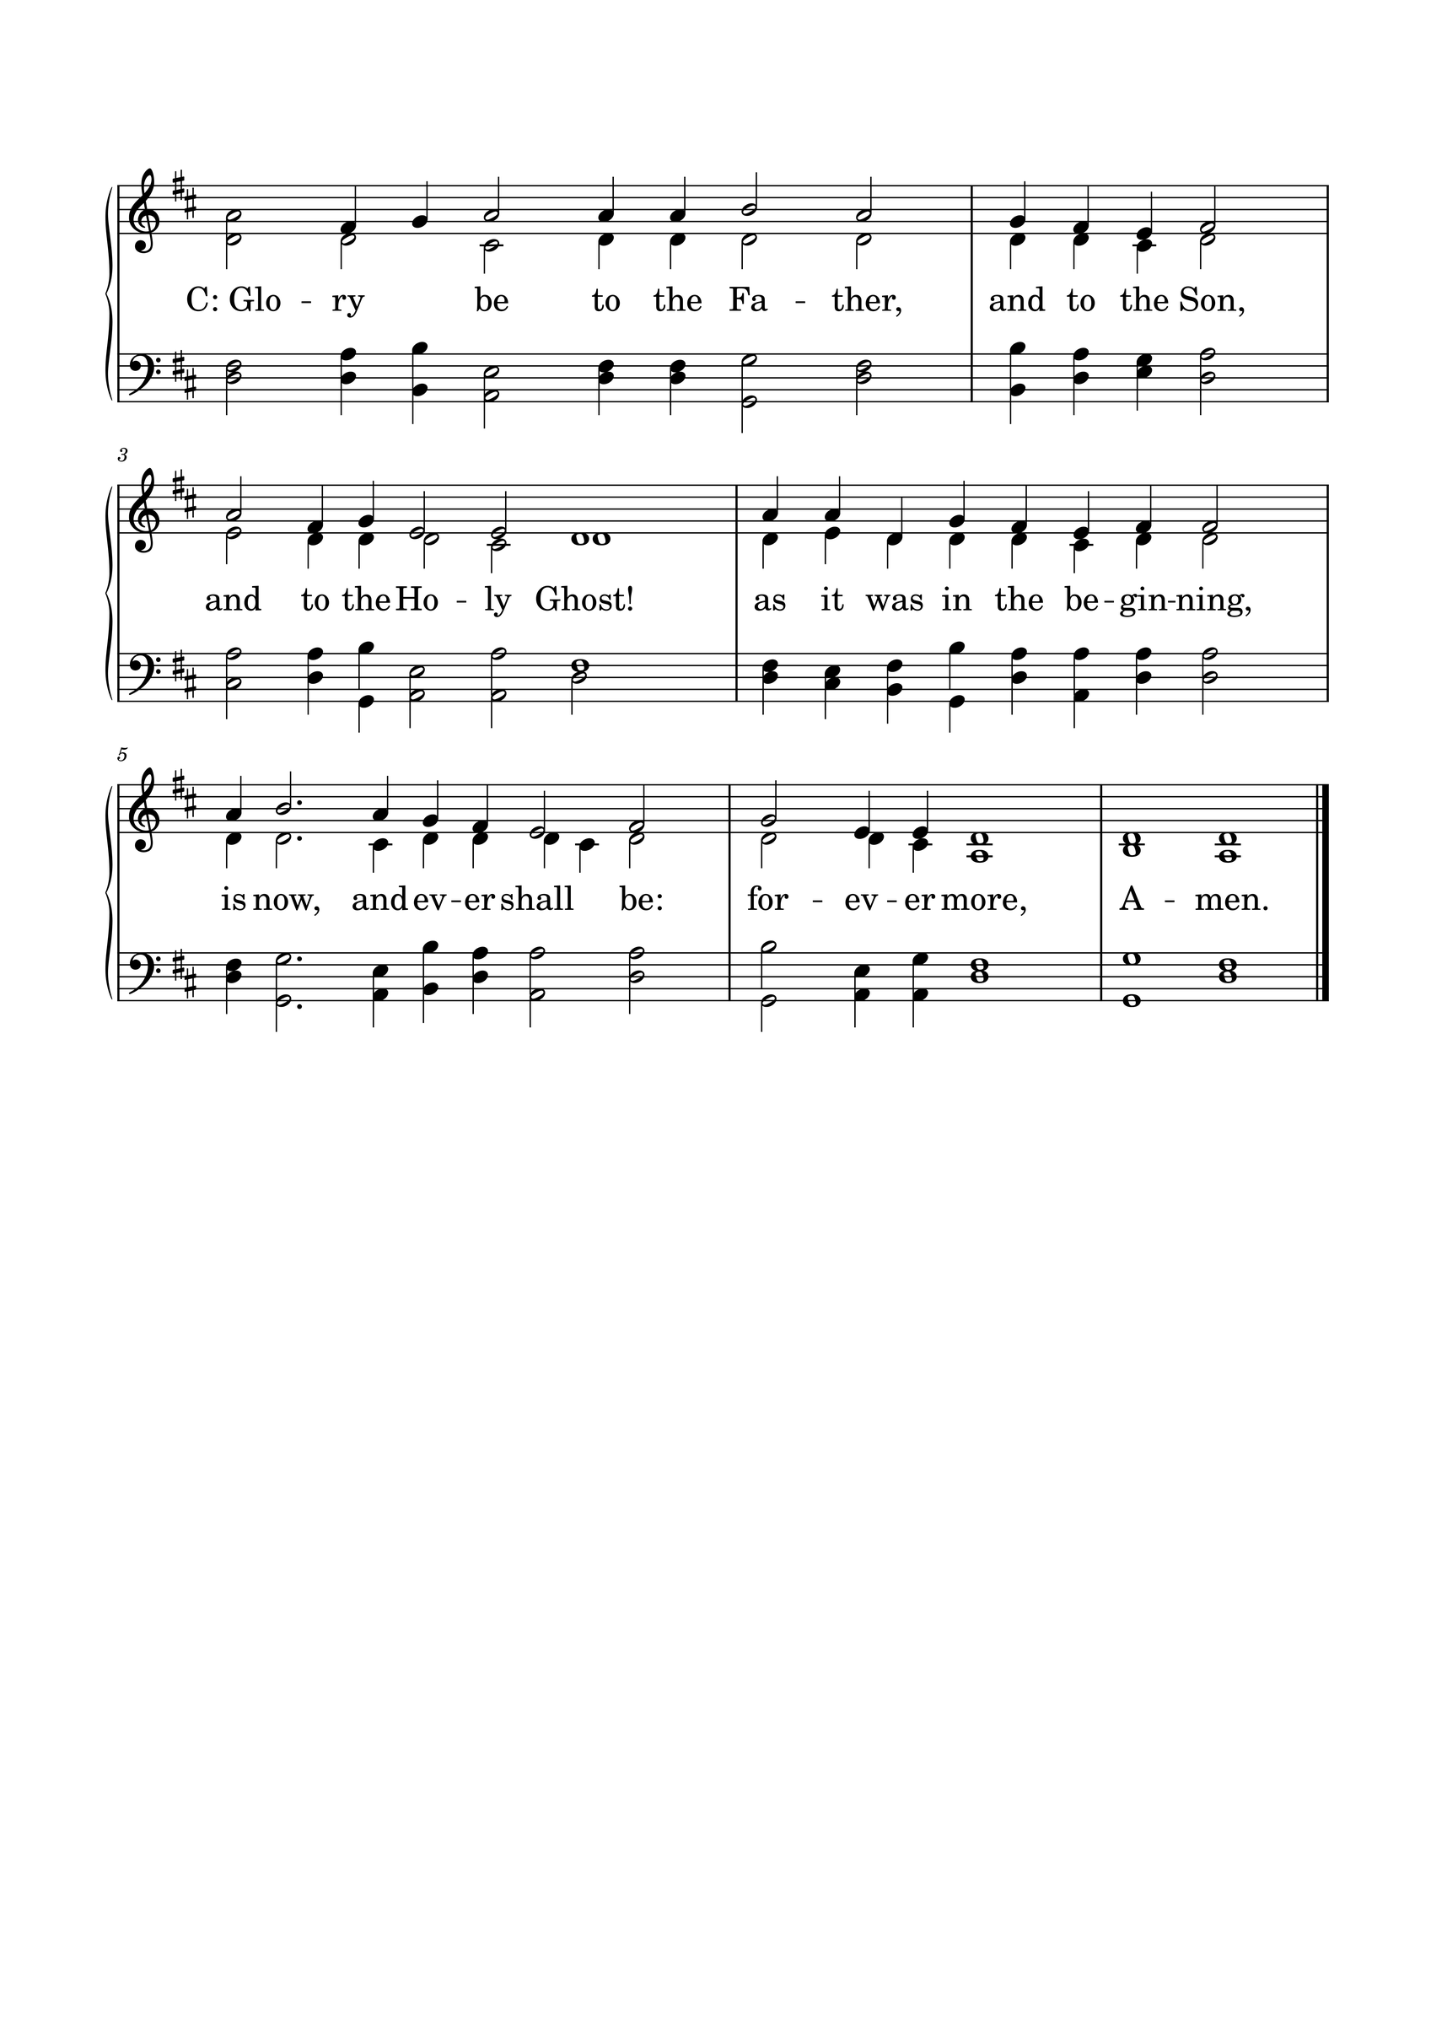

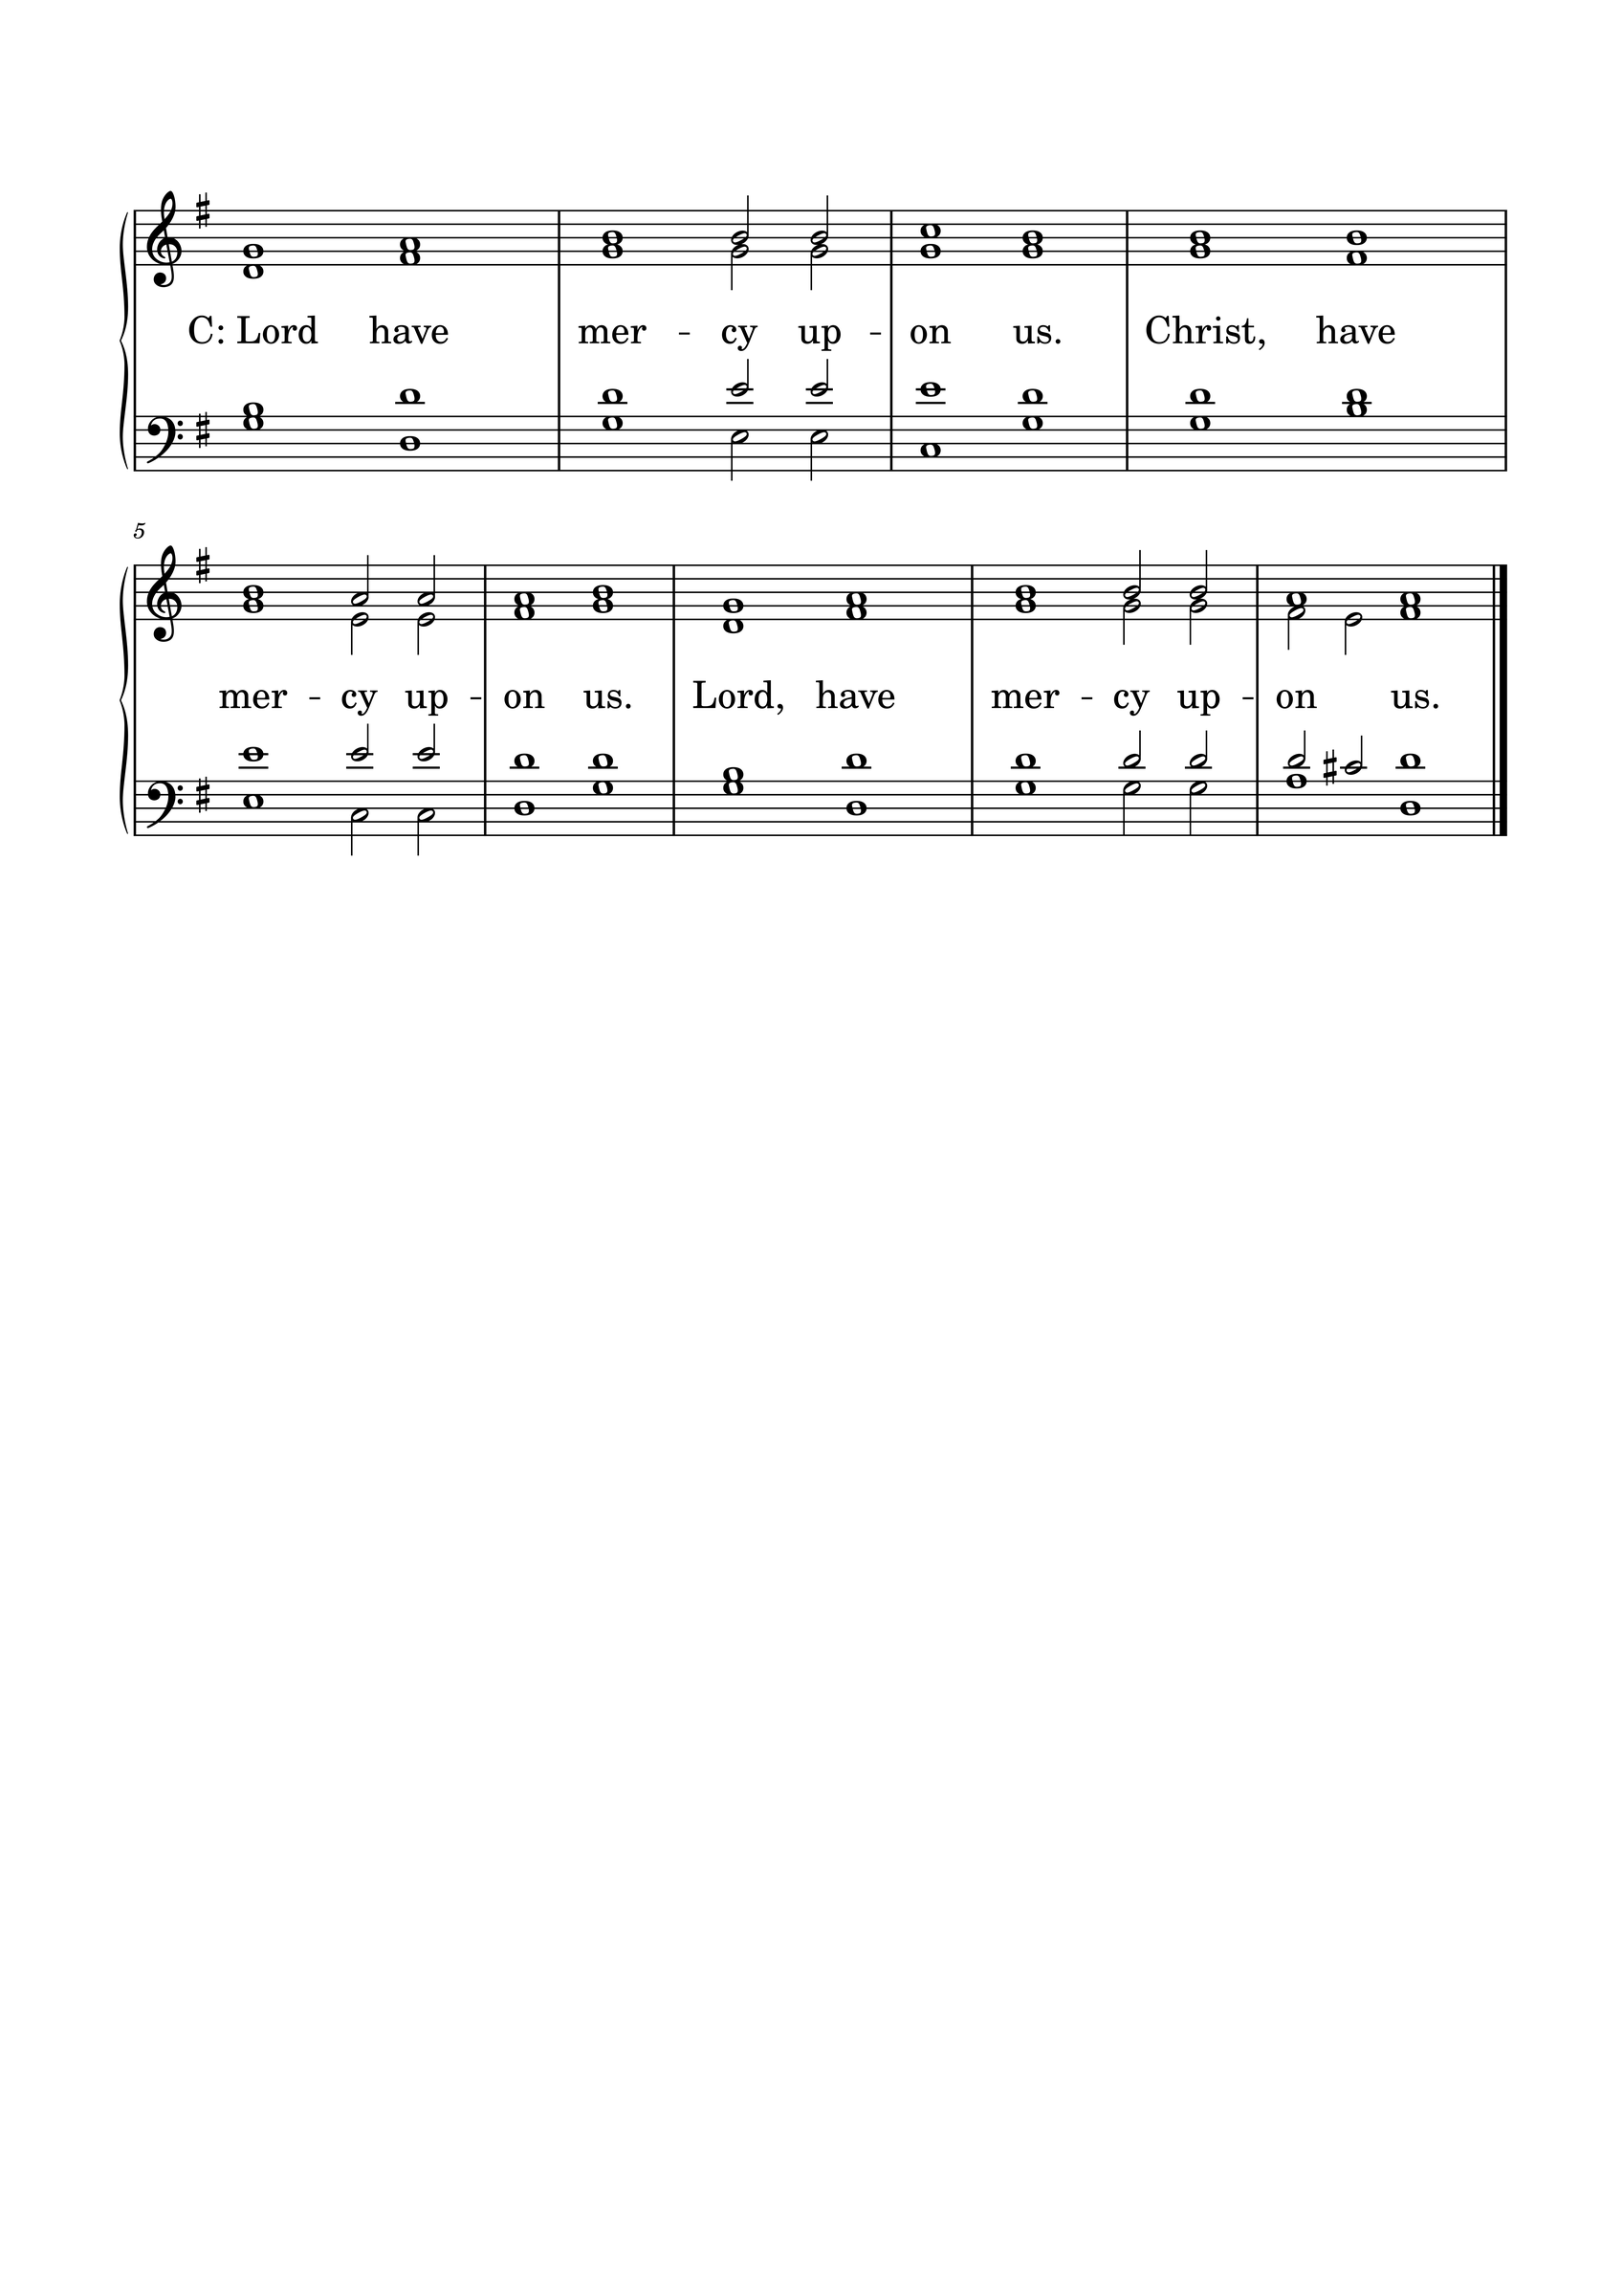KYRIE

GLORIA
The Lutheran Hymnal hymn 244 Verses 1 & 2
C: 1. Glory be to God the Father,
Glory be to God the Son,
Glory be to God the Spirit:
Great Jehovah, Three in One!
Glory, glory,
While eternal ages run!

2. Glory be to Him who loved us,
Washed us from each spot and stain;
Glory be to Him who bought us,
Made us kings with Him to reign!
Glory, glory,
To the Lamb that once was slain!

THE COLLECT
L : Let us pray.
L :
Lord Jesus Christ, by Your death and resurrection You have turned our hour of death into the hour of life. Strengthen our faith in Your life-giving Word, that through every trial we may trust Your promises and finally enter the joy of life everlasting; for You live and reign with the Father and the Holy Spirit, one God, now and forever. Amen.
C: Amen.

FIRST SCRIPTURE READING
L: (The congregation may be seated.) The First Scripture Reading for 23rd Sunday after Trinity is written in the 1st chapter of 1 Timothy, beginning at verse 3.
[3] As I urged you when I went into Macedonia—remain in Ephesus that you may charge some that they teach no other doctrine, [4] nor give heed to fables and endless genealogies, which cause disputes rather than godly edification which is in faith. [5] Now the purpose of the commandment is love from a pure heart, from a good conscience, and from sincere faith, [6] from which some, having strayed, have turned aside to idle talk, [7] desiring to be teachers of the law, understanding neither what they say nor the things which they affirm.
[8] But we know that the law is good if one uses it lawfully, [9] knowing this: that the law is not made for a righteous person, but for the lawless and insubordinate, for the ungodly and for sinners, for the unholy and profane, for murderers of fathers and murderers of mothers, for manslayers, [10] for fornicators, for sodomites, for kidnappers, for liars, for perjurers, and if there is any other thing that is contrary to sound doctrine, [11] according to the glorious gospel of the blessed God which was committed to my trust.
[12] And I thank Christ Jesus our Lord who has enabled me, because He counted me faithful, putting me into the ministry,
L: Here ends the First Scripture Reading.

SECOND SCRIPTURE READING
L: The Second Scripture Reading is written in the 5th chapter of John, beginning at verse 19.
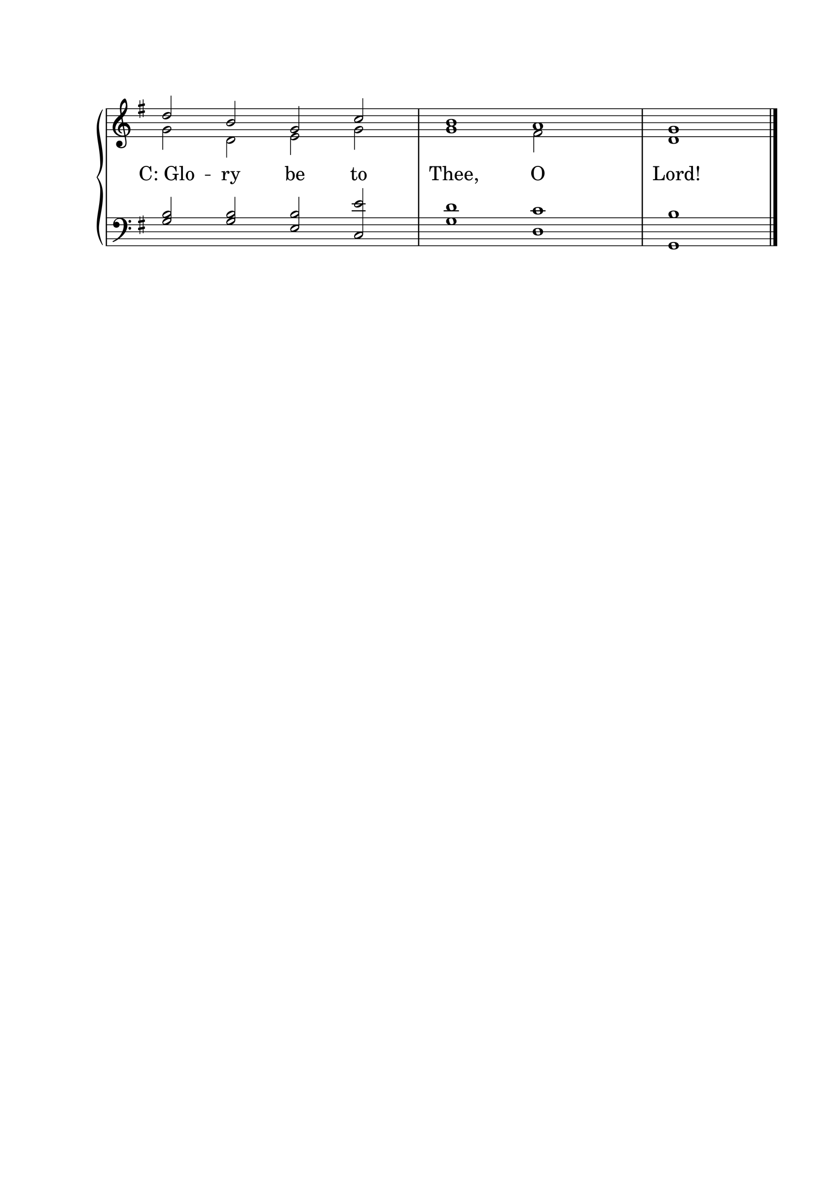

[19] Then Jesus answered and said to them, “Most assuredly, I say to you, the Son can do nothing of Himself, but what He sees the Father do; for whatever He does, the Son also does in like manner. [20] For the Father loves the Son, and shows Him all things that He Himself does; and He will show Him greater works than these, that you may marvel. [21] For as the Father raises the dead and gives life to them, even so the Son gives life to whom He will. [22] For the Father judges no one, but has committed all judgment to the Son, [23] that all should honor the Son just as they honor the Father. He who does not honor the Son does not honor the Father who sent Him.
[24] “Most assuredly, I say to you, he who hears My word and believes in Him who sent Me has everlasting life, and shall not come into judgment, but has passed from death into life. [25] Most assuredly, I say to you, the hour is coming, and now is, when the dead will hear the voice of the Son of God; and those who hear will live. [26] For as the Father has life in Himself, so He has granted the Son to have life in Himself, [27] and has given Him authority to execute judgment also, because He is the Son of Man. [28] Do not marvel at this; for the hour is coming in which all who are in the graves will hear His voice [29] and come forth—those who have done good, to the resurrection of life, and those who have done evil, to the resurrection of condemnation. [30] I can of Myself do nothing. As I hear, I judge; and My judgment is righteous, because I do not seek My own will but the will of the Father who sent Me.

L: Here ends the Second Scripture Reading.

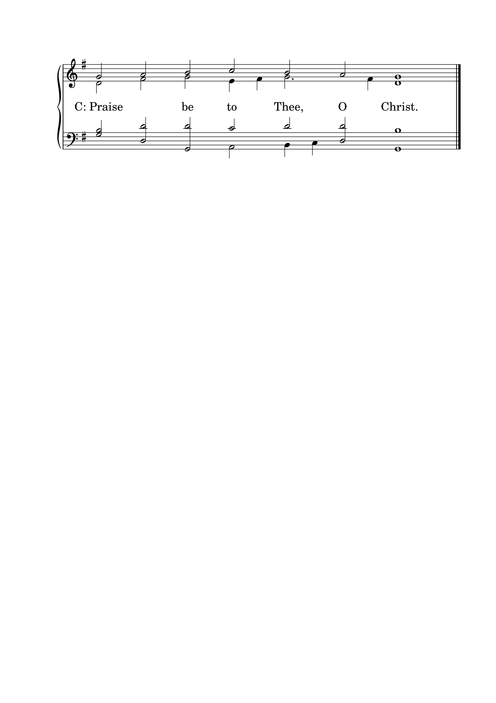

THE APOSTLES' CREED
C: I believe in God the Father almighty, maker of heaven and earth. And in Jesus Christ, His only Son, our Lord, who was conceived by the Holy Spirit, born of the Virgin Mary; suffered under Pontius Pilate, was crucified, died, and was buried. He descended into hell. The third day He rose again from the dead. He ascended into heaven and is seated at the right hand of God the Father almighty. From there He will come to judge the living and the dead. I believe in the Holy Spirit; the holy Christian Church, the communion of saints; the forgiveness of sins; the resurrection of the body; and the life everlasting. Amen.

HYMN 355

THE SERMON
Sermon Text: John 4:46-54 NKJ
"So Jesus came again to Cana of Galilee where He had made the water wine. And there was a certain nobleman whose son was sick at Capernaum. 47 When he heard that Jesus had come out of Judea into Galilee, he went to Him and implored Him to come down and heal his son, for he was at the point of death. 48 Then Jesus said to him, "Unless you people see signs and wonders, you will by no means believe." 49 The nobleman said to Him, "Sir, come down before my child dies!" 50 Jesus said to him, "Go your way; your son lives." So the man believed the word that Jesus spoke to him, and he went his way. 51 And as he was now going down, his servants met him and told him, saying, "Your son lives!" 52 Then he inquired of them the hour when he got better. And they said to him, "Yesterday at the seventh hour the fever left him." 53 So the father knew that it was at the same hour in which Jesus said to him, "Your son lives." And he himself believed, and his whole household. 54 This again is the second sign Jesus did when He had come out of Judea into Galilee."

Sermon Theme: It Is the Hour of Life

L: (The congregation rises.) And may the peace of God, which surpasses all understanding, guard your hearts and minds through Christ Jesus, amen.

THE OFFERTORY
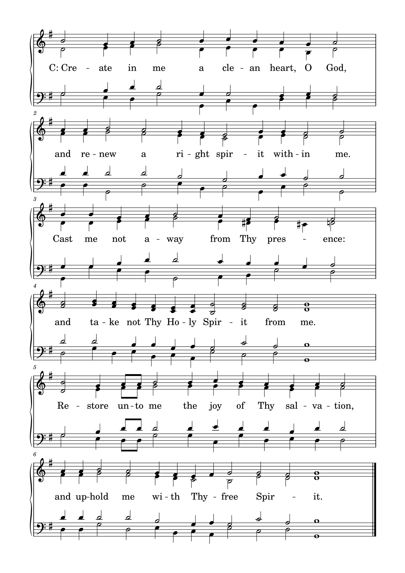

L: Please be seated.

(An offering may be collected at this time, or the congregation may be informed that the offering plate is located at the back of the church.)

HYMN 409

GENERAL PRAYER

THE LORD'S PRAYER
C: Our Father, who art in heaven, hallowed be Your name; Your kingdom come; Your will be done on earth as it is in heaven. Give us this day our daily bread; and forgive us our trespasses, as we forgive those who trespass against us; and lead us not into temptation; but deliver us from evil. For Yours is the kingdom and the power and the glory forever and ever. Amen.

(If Communion is celebrated, refer to the order of Holy Communion.)

FINAL HYMN 46

THE BENEDICTION
L : (The congregation rises.) The Lord bless you and keep you. The Lord make His face shine upon you and be gracious to you. The Lord lift up His countenance upon you and give you peace.
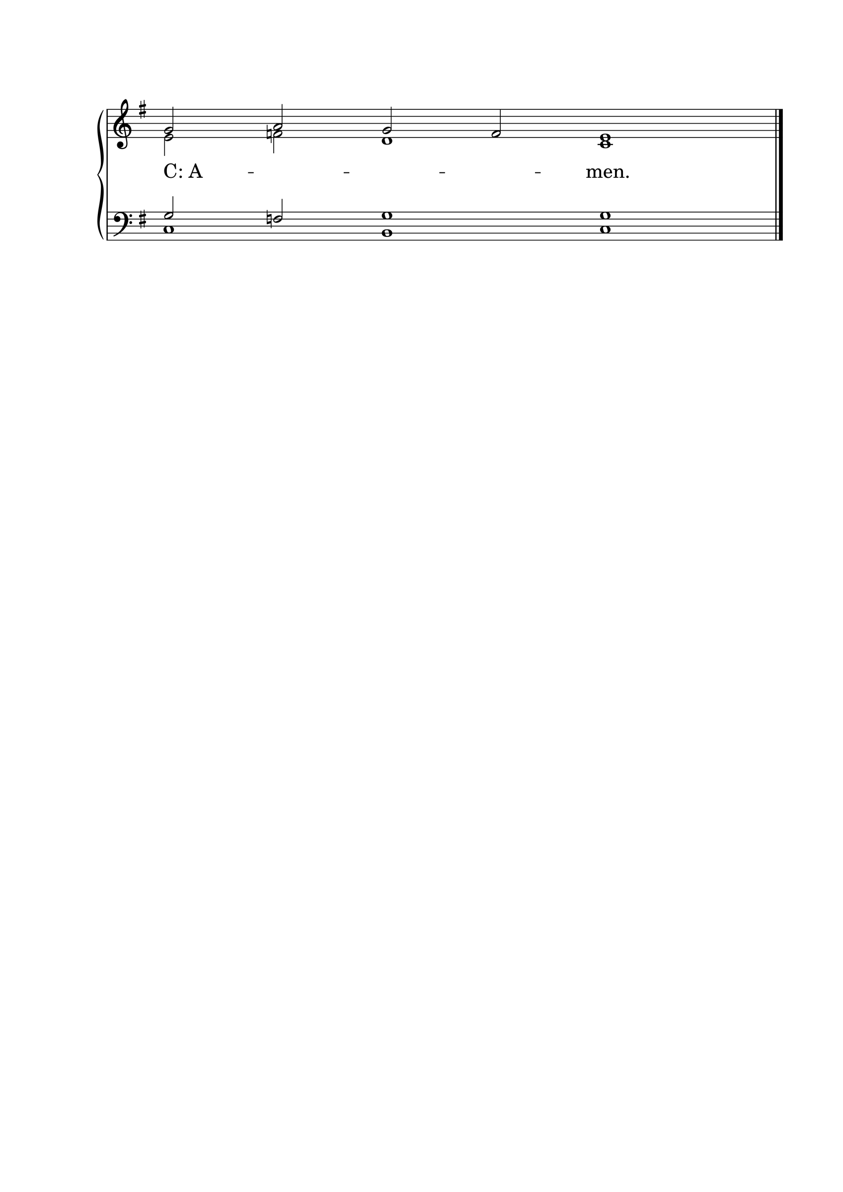

ANNOUNCEMENTS
• CALL NEWS Pastor Rob Sauers of Immanuel Lutheran Church, Winter Haven, FL, has returned the call from the CLC Board of Missions to serve as Part-Time Missionary to India. <> Pastor Frank Gantt of Zion Ev. Lutheran Church, Loganville, GA, and Faith Lutheran Church, Manchester, MO, has returned the call to St. Luke’s Ev. Lutheran Church, Lemmon, SD. <> Pastor Paul Krause of Trinity Lutheran Church, Watertown, SD, and Zion Lutheran Church, Hidewood Township, SD, has accepted the call to Mt. Zion Lutheran Church, Madison Heights, MI. <> Pastor Neal Radichel of Messiah Lutheran Church, Eau Claire, WI, has received the call to Holy Cross Ev. Lutheran Church, Phoenix, AZ. <> Pastor Michael Wilke of Gethsemane Lutheran Church, Saginaw, MI, has received the call to Gift of God Lutheran Church, Mapleton, ND, and to St. Paul’s Lutheran Church, Ponsford, MN.

“Scripture taken from the New King James Version®. Copyright © 1982 by Thomas Nelson. Used by permission. All rights reserved.”

