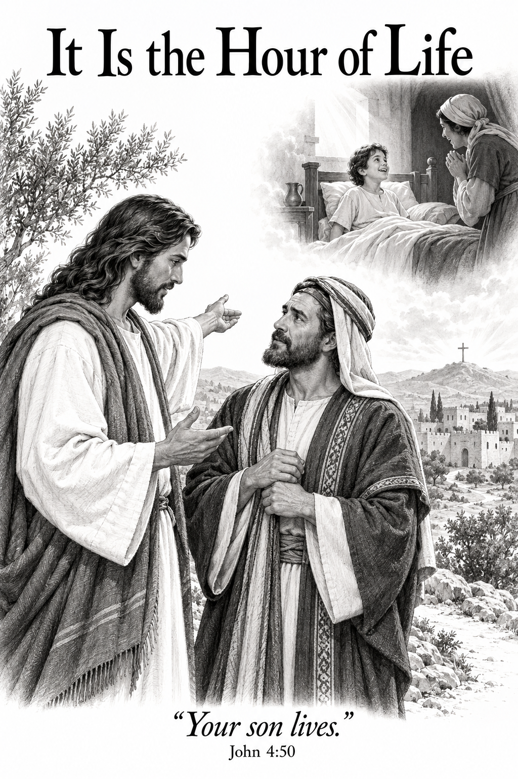
A Church of the Lutheran Confession
November 1, 2026
23rd Sunday after Trinity

HYMNS
23; 355; 409; 46

PSALM OF THE DAY
L: Lord, You have been favorable to Your land;
C: You have brought back the captivity of Jacob.
L: You have forgiven the iniquity of Your people;
C: You have covered all their sin. Selah
L: You have taken away all Your wrath;
C: You have turned from the fierceness of Your anger.
L: Restore us, O God of our salvation,
C: And cause Your anger toward us to cease.
L: Will You be angry with us forever?
C: Will You prolong Your anger to all generations?
L: Will You not revive us again,
C: That Your people may rejoice in You?
L: Show us Your mercy, Lord,
C: And grant us Your salvation. (Psalm 85)

THE COLLECT
Lord Jesus Christ, by Your death and resurrection You have turned our hour of death into the hour of life. Strengthen our faith in Your life-giving Word, that through every trial we may trust Your promises and finally enter the joy of life everlasting; for You live and reign with the Father and the Holy Spirit, one God, now and forever. Amen.

FIRST SCRIPTURE READING
1 Timothy 1:3-12
[3] As I urged you when I went into Macedonia—remain in Ephesus that you may charge some that they teach no other doctrine, [4] nor give heed to fables and endless genealogies, which cause disputes rather than godly edification which is in faith. [5] Now the purpose of the commandment is love from a pure heart, from a good conscience, and from sincere faith, [6] from which some, having strayed, have turned aside to idle talk, [7] desiring to be teachers of the law, understanding neither what they say nor the things which they affirm.
[8] But we know that the law is good if one uses it lawfully, [9] knowing this: that the law is not made for a righteous person, but for the lawless and insubordinate, for the ungodly and for sinners, for the unholy and profane, for murderers of fathers and murderers of mothers, for manslayers, [10] for fornicators, for sodomites, for kidnappers, for liars, for perjurers, and if there is any other thing that is contrary to sound doctrine, [11] according to the glorious gospel of the blessed God which was committed to my trust.
[12] And I thank Christ Jesus our Lord who has enabled me, because He counted me faithful, putting me into the ministry,

SECOND SCRIPTURE READING
John 5:19-30
[19] Then Jesus answered and said to them, “Most assuredly, I say to you, the Son can do nothing of Himself, but what He sees the Father do; for whatever He does, the Son also does in like manner. [20] For the Father loves the Son, and shows Him all things that He Himself does; and He will show Him greater works than these, that you may marvel. [21] For as the Father raises the dead and gives life to them, even so the Son gives life to whom He will. [22] For the Father judges no one, but has committed all judgment to the Son, [23] that all should honor the Son just as they honor the Father. He who does not honor the Son does not honor the Father who sent Him.
[24] “Most assuredly, I say to you, he who hears My word and believes in Him who sent Me has everlasting life, and shall not come into judgment, but has passed from death into life. [25] Most assuredly, I say to you, the hour is coming, and now is, when the dead will hear the voice of the Son of God; and those who hear will live. [26] For as the Father has life in Himself, so He has granted the Son to have life in Himself, [27] and has given Him authority to execute judgment also, because He is the Son of Man. [28] Do not marvel at this; for the hour is coming in which all who are in the graves will hear His voice [29] and come forth—those who have done good, to the resurrection of life, and those who have done evil, to the resurrection of condemnation. [30] I can of Myself do nothing. As I hear, I judge; and My judgment is righteous, because I do not seek My own will but the will of the Father who sent Me.

THE SERMON
Sermon Text: John 4:46-54 NKJ
"So Jesus came again to Cana of Galilee where He had made the water wine. And there was a certain nobleman whose son was sick at Capernaum. 47 When he heard that Jesus had come out of Judea into Galilee, he went to Him and implored Him to come down and heal his son, for he was at the point of death. 48 Then Jesus said to him, "Unless you people see signs and wonders, you will by no means believe." 49 The nobleman said to Him, "Sir, come down before my child dies!" 50 Jesus said to him, "Go your way; your son lives." So the man believed the word that Jesus spoke to him, and he went his way. 51 And as he was now going down, his servants met him and told him, saying, "Your son lives!" 52 Then he inquired of them the hour when he got better. And they said to him, "Yesterday at the seventh hour the fever left him." 53 So the father knew that it was at the same hour in which Jesus said to him, "Your son lives." And he himself believed, and his whole household. 54 This again is the second sign Jesus did when He had come out of Judea into Galilee."

Sermon Theme: It Is the Hour of Life

ANNOUNCEMENTS
• CALL NEWS Pastor Rob Sauers of Immanuel Lutheran Church, Winter Haven, FL, has returned the call from the CLC Board of Missions to serve as Part-Time Missionary to India. <> Pastor Frank Gantt of Zion Ev. Lutheran Church, Loganville, GA, and Faith Lutheran Church, Manchester, MO, has returned the call to St. Luke’s Ev. Lutheran Church, Lemmon, SD. <> Pastor Paul Krause of Trinity Lutheran Church, Watertown, SD, and Zion Lutheran Church, Hidewood Township, SD, has accepted the call to Mt. Zion Lutheran Church, Madison Heights, MI. <> Pastor Neal Radichel of Messiah Lutheran Church, Eau Claire, WI, has received the call to Holy Cross Ev. Lutheran Church, Phoenix, AZ. <> Pastor Michael Wilke of Gethsemane Lutheran Church, Saginaw, MI, has received the call to Gift of God Lutheran Church, Mapleton, ND, and to St. Paul’s Lutheran Church, Ponsford, MN.

“Scripture taken from the New King James Version®. Copyright © 1982 by Thomas Nelson. Used by permission. All rights reserved.”

