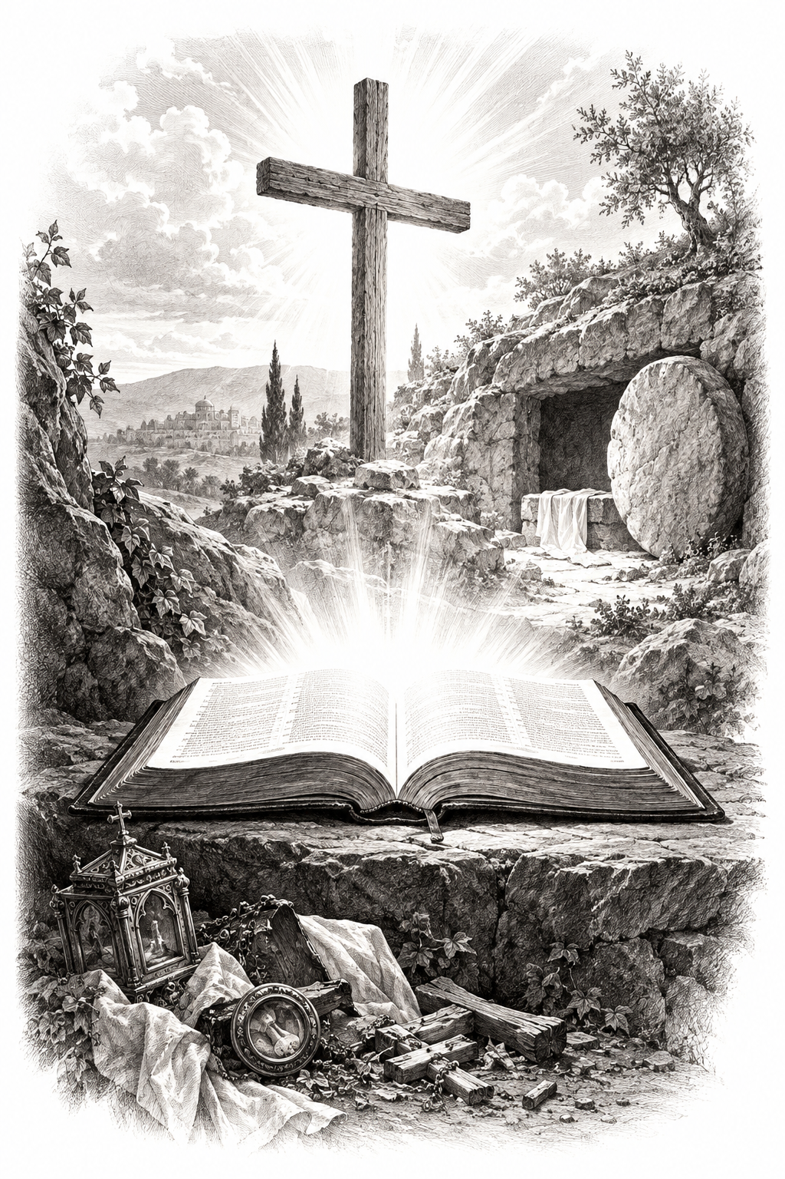

THE COMMON SERVICE
This liturgy is adapted from the Common Service Book of the Lutheran Church (1917-1918) and Evangelical Lutheran Hymn-book (1912), which are in the public domain. Bold faced congregational responses may be spoken or sung as desired.

OPENING HYMN 262
Leader: (The congregation rises.) In the name of the Father, and of the Son, and of the Holy Spirit.
Congregation: Amen.

THE CONFESSION OF SINS
L : Beloved in the Lord! Let us draw near with a true heart and confess our sins to God our Father, asking Him, in the name of our Lord Jesus Christ, to grant us forgiveness.
L: Our help is in the name of the Lord.
C: Who made heaven and earth.
L: I said, I will confess my transgressions to the Lord.
C: And You forgave the iniquity of my sin.
L : Almighty God, our Maker and Redeemer, we poor sinners confess to You that we are by nature sinful and unclean, and that we have sinned against You by thought, word, and deed. Therefore we flee for refuge to Your infinite mercy, seeking and imploring Your grace for the sake of our Lord Jesus Christ.
C: O most merciful God, who has given Your only-begotten Son to die for us, have mercy upon us, and for His sake grant us remission of all our sins; and by Your Holy Spirit increase in us true knowledge of You and of Your will, and true obedience to Your Word, so that by Your grace we may come to everlasting life; through Jesus Christ our Lord. Amen.
L : Almighty God, our heavenly Father, has had mercy upon us and has given His only Son to die for us, and for His sake forgives us all our sins. To those who believe in His name He gives power to become the children of God and bestows upon them His Holy Spirit. Whoever believes and is baptized will be saved. Grant this, O Lord, to us all.
C: Amen.

PSALM OF THE DAY
L: God is our refuge and strength,
C: A very present help in trouble.
L: Therefore we will not fear, Even though the earth be removed,
C: And though the mountains be carried into the midst of the sea;
L: Though its waters roar and be troubled,
C: Though the mountains shake with its swelling. Selah
L: There is a river whose streams shall make glad the city of God,
C: The holy place of the tabernacle of the Most High.
L: God is in the midst of her, she shall not be moved;
C: God shall help her, just at the break of dawn.
L: The nations raged, the kingdoms were moved;
C: He uttered His voice, the earth melted.
L: The Lord of hosts is with us;
C: The God of Jacob is our refuge. Selah (Psalm 46)

GLORIA PATRI
C: Glory be to the Father, and to the Son, and to the Holy Spirit; as it was in the beginning, is now, and will be forever. Amen.

KYRIE
C: Lord, have mercy upon us.
Christ, have mercy upon us.
Lord, have mercy upon us.
GLORIA
The Lutheran Hymnal hymn 244 Verses 1 & 2

C: 1. Glory be to God the Father,
Glory be to God the Son,
Glory be to God the Spirit:
Great Jehovah, Three in One!
Glory, glory,
While eternal ages run!

2. Glory be to Him who loved us,
Washed us from each spot and stain;
Glory be to Him who bought us,
Made us kings with Him to reign!
Glory, glory,
To the Lamb that once was slain!

THE COLLECT
L : Let us pray.
L :
We thank Thee, almighty God and Father, that Thou hast had such fatherly mercy on us, and that, through Thy precious instrument, Martin Luther, Thou hast let the light of Thy holy Word, that alone justifieth, be preached clear and pure, to the shame of all corruption and idolatry, and we beseech Thee, govern us by Thy Holy Spirit, that we may ceaselessly trust the Gospel, live it worthily, and, in the end, die happy and blessed in such confidence, through Jesus Christ, Thy Son, our Lord, who liveth and reigneth with Thee and the Holy Ghost, one true God, world without end. Amen.
C: Amen.

FIRST SCRIPTURE READING
L: (The congregation may be seated.) The First Scripture Reading for Reformation Sunday is written in the 14th chapter of Revelation, beginning at verse 6.
[6] Then I saw another angel flying in the midst of heaven, having the everlasting gospel to preach to those who dwell on the earth—to every nation, tribe, tongue, and people— [7] saying with a loud voice, “Fear God and give glory to Him, for the hour of His judgment has come; and worship Him who made heaven and earth, the sea and springs of water.”
[12] Here is the patience of the saints; here are those who keep the commandments of God and the faith of Jesus.
[13] Then I heard a voice from heaven saying to me, “Write: ‘Blessed are the dead who die in the Lord from now on.’ ”
“Yes,” says the Spirit, “that they may rest from their labors, and their works follow them.”
L: Here ends the First Scripture Reading.

SECOND SCRIPTURE READING
L: The Second Scripture Reading is written in the 11th chapter of Matthew, beginning at verse 12.
C: Glory be to You, O Lord.
[12] And from the days of John the Baptist until now the kingdom of heaven suffers violence, and the violent take it by force. [13] For all the prophets and the law prophesied until John. [14] And if you are willing to receive it, he is Elijah who is to come. [15] He who has ears to hear, let him hear!

L: Here ends the Second Scripture Reading.
C: Praise be to You, O Christ.

THE APOSTLES' CREED
C: I believe in God the Father almighty, maker of heaven and earth. And in Jesus Christ, His only Son, our Lord, who was conceived by the Holy Spirit, born of the Virgin Mary; suffered under Pontius Pilate, was crucified, died, and was buried. He descended into hell. The third day He rose again from the dead. He ascended into heaven and is seated at the right hand of God the Father almighty. From there He will come to judge the living and the dead. I believe in the Holy Spirit; the holy Christian Church, the communion of saints; the forgiveness of sins; the resurrection of the body; and the life everlasting. Amen.

HYMN 265

THE SERMON
Sermon Text: Proverbs 26:11 KJV
"As a dog returneth to his vomit, so a fool returneth to his folly."

Sermon Theme: Old Habits Die Hard

L: (The congregation rises.) And may the peace of God, which surpasses all understanding, guard your hearts and minds through Christ Jesus, amen.

THE OFFERTORY
C: Create in me a clean heart, O God, and renew a right spirit within me. Cast me not away from Your presence, and take not Your Holy Spirit from me. Restore to me the joy of Your salvation, and uphold me with Your free Spirit.
L: Please be seated.

(An offering may be collected at this time, or the congregation may be informed that the offering plate is located at the back of the church.)

HYMN 266

GENERAL PRAYER

THE LORD'S PRAYER
C: Our Father, who art in heaven, hallowed be Your name; Your kingdom come; Your will be done on earth as it is in heaven. Give us this day our daily bread; and forgive us our trespasses, as we forgive those who trespass against us; and lead us not into temptation; but deliver us from evil. For Yours is the kingdom and the power and the glory forever and ever. Amen.

(If Communion is celebrated, refer to the order of Holy Communion.)

FINAL HYMN 283

THE BENEDICTION
L : (The congregation rises.) The Lord bless you and keep you. The Lord make His face shine upon you and be gracious to you. The Lord lift up His countenance upon you and give you peace.
C: Amen.

ANNOUNCEMENTS
• CALL NEWS: Pastor Timothy Daub of Prince of Peace Lutheran Church, Hecla, SD, Zion Ev. Lutheran Church, Aberdeen, SD, and Redeemer Lutheran Church, Bowdle, SD, has accepted the call from the CLC Board of Missions to serve as Part-Time Missionary to Mexico with the approval of his congregation. <> Pastor Neal Radichel of Messiah Lutheran Church, Eau Claire, WI, has received the call to Holy Cross Ev. Lutheran Church, Phoenix, AZ. <> Missionary Todd Ohlmann has returned the call to Messiah Lutheran Church, Eau Claire, WI. <> Pastor Michael Wilke of Gethsemane Lutheran Church, Saginaw, MI, has received the call to Gift of God Lutheran Church, Mapleton, ND, and to St. Paul’s Lutheran Church, Ponsford, MN. <> Pastor Rob Sauers of Immanuel Lutheran Church, Winter Haven, FL, has received the call from the CLC Board of Missions to serve as Part-Time Missionary to India. <> Pastor Frank Gantt of Zion Ev. Lutheran Church, Loganville, GA, and Faith Lutheran Church, Manchester, MO, has received the call to St. Luke’s Ev. Lutheran Church, Lemmon, SD. <> Pastor Paul Krause of Trinity Lutheran Church, Watertown, SD, and Zion Lutheran Church, Hidewood Township, SD, has received the call to Mt. Zion Lutheran Church, Madison Heights, MI.

“Scripture taken from the New King James Version®. Copyright © 1982 by Thomas Nelson. Used by permission. All rights reserved.”

