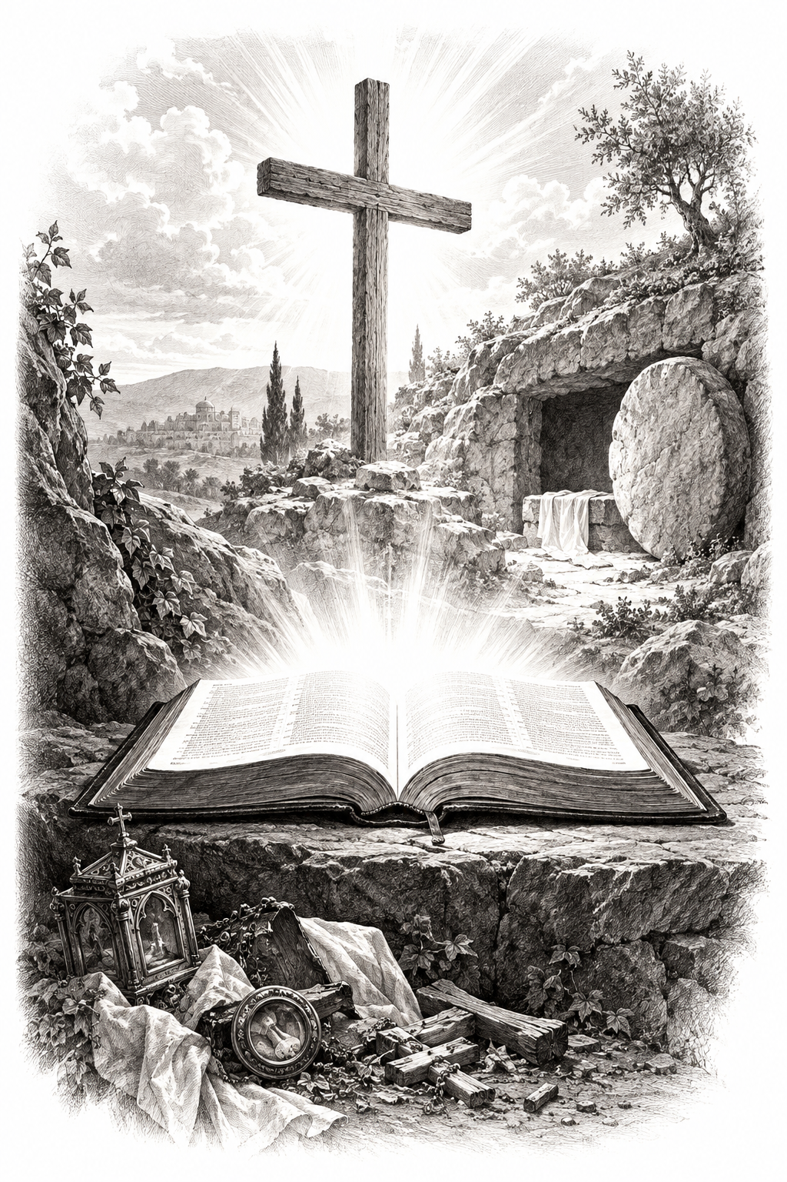
A Church of the Lutheran Confession
October 25, 2026
Reformation Sunday

HYMNS
262; 265; 266; 283

PSALM OF THE DAY
L: God is our refuge and strength,
C: A very present help in trouble.
L: Therefore we will not fear, Even though the earth be removed,
C: And though the mountains be carried into the midst of the sea;
L: Though its waters roar and be troubled,
C: Though the mountains shake with its swelling. Selah
L: There is a river whose streams shall make glad the city of God,
C: The holy place of the tabernacle of the Most High.
L: God is in the midst of her, she shall not be moved;
C: God shall help her, just at the break of dawn.
L: The nations raged, the kingdoms were moved;
C: He uttered His voice, the earth melted.
L: The Lord of hosts is with us;
C: The God of Jacob is our refuge. Selah (Psalm 46)

THE COLLECT
We thank Thee, almighty God and Father, that Thou hast had such fatherly mercy on us, and that, through Thy precious instrument, Martin Luther, Thou hast let the light of Thy holy Word, that alone justifieth, be preached clear and pure, to the shame of all corruption and idolatry, and we beseech Thee, govern us by Thy Holy Spirit, that we may ceaselessly trust the Gospel, live it worthily, and, in the end, die happy and blessed in such confidence, through Jesus Christ, Thy Son, our Lord, who liveth and reigneth with Thee and the Holy Ghost, one true God, world without end. Amen.

FIRST SCRIPTURE READING
Revelation 14:6-7, 12-13
[6] Then I saw another angel flying in the midst of heaven, having the everlasting gospel to preach to those who dwell on the earth—to every nation, tribe, tongue, and people— [7] saying with a loud voice, “Fear God and give glory to Him, for the hour of His judgment has come; and worship Him who made heaven and earth, the sea and springs of water.”
[12] Here is the patience of the saints; here are those who keep the commandments of God and the faith of Jesus.
[13] Then I heard a voice from heaven saying to me, “Write: ‘Blessed are the dead who die in the Lord from now on.’ ”
“Yes,” says the Spirit, “that they may rest from their labors, and their works follow them.”

SECOND SCRIPTURE READING
Matthew 11:12-15
[12] And from the days of John the Baptist until now the kingdom of heaven suffers violence, and the violent take it by force. [13] For all the prophets and the law prophesied until John. [14] And if you are willing to receive it, he is Elijah who is to come. [15] He who has ears to hear, let him hear!

THE SERMON
Sermon Text: Proverbs 26:11 KJV
"As a dog returneth to his vomit, so a fool returneth to his folly."

Sermon Theme: Old Habits Die Hard

ANNOUNCEMENTS
• CALL NEWS: Pastor Timothy Daub of Prince of Peace Lutheran Church, Hecla, SD, Zion Ev. Lutheran Church, Aberdeen, SD, and Redeemer Lutheran Church, Bowdle, SD, has accepted the call from the CLC Board of Missions to serve as Part-Time Missionary to Mexico with the approval of his congregation. <> Pastor Neal Radichel of Messiah Lutheran Church, Eau Claire, WI, has received the call to Holy Cross Ev. Lutheran Church, Phoenix, AZ. <> Missionary Todd Ohlmann has returned the call to Messiah Lutheran Church, Eau Claire, WI. <> Pastor Michael Wilke of Gethsemane Lutheran Church, Saginaw, MI, has received the call to Gift of God Lutheran Church, Mapleton, ND, and to St. Paul’s Lutheran Church, Ponsford, MN. <> Pastor Rob Sauers of Immanuel Lutheran Church, Winter Haven, FL, has received the call from the CLC Board of Missions to serve as Part-Time Missionary to India. <> Pastor Frank Gantt of Zion Ev. Lutheran Church, Loganville, GA, and Faith Lutheran Church, Manchester, MO, has received the call to St. Luke’s Ev. Lutheran Church, Lemmon, SD. <> Pastor Paul Krause of Trinity Lutheran Church, Watertown, SD, and Zion Lutheran Church, Hidewood Township, SD, has received the call to Mt. Zion Lutheran Church, Madison Heights, MI.

“Scripture taken from the New King James Version®. Copyright © 1982 by Thomas Nelson. Used by permission. All rights reserved.”

